Week 8 | Topic: Using the Engineering Cycle to Create A Wind Turbine
Lesson Topic: | Essential Question: How can we use the engineering cycle to create the most effective wind turbine?
Objective: | Students will be able to:  - Apply the engineering design process to create and optimize a solution for the wind turbine challenge.  - Use a variety of materials and tools, including 3D printers, to construct solutions.  - Communicate their solutions and constraints to other students in order to collectively optimize solutions.
Standards Addressed: | SEEd Science and Engineering Practices  - Constructing explanations and designing solutions: Students construct explanations about the world and design solutions to problems using observations that are consistent with current evidence and scientific principles.  - Obtaining, evaluating, and communicating information: Students obtain, evaluate, and derive meaning from scientific information or presented evidence using appropriate scientific language. They communicate their findings clearly and persuasively in a variety of ways including written text, graphs, diagrams, charts, tables, or orally.  - Engaging in argument from evidence: Students support their best explanations with lines of reasoning.  - Planning and carrying out investigations: Students plan and conduct scientific investigations in order to test, revise, or develop explanations.  - Analyzing and interpreting data: Students analyze various types of data in order to create valid interpretations or to assess claims/conclusions.  - Using mathematics and computational thinking: Students use fundamental tools in science to compute relationships and interpret results.  - Constructing explanations and designing solutions: Students construct explanations about the world and design solutions to problems using observations that are consistent with current evidence and scientific principles.  SEEd Crosscutting Concepts  - Patterns: Students observe patterns to organize and classify factors that influence relationships.  SEEd Disciplinary Core Ideas  - (ETS1.A) Defining and Delimiting an Engineering Problem  - (ETS1.B) Developing Possible Solutions  - (ETS1.C) Optimizing the Design Solution  Engineering and Technology Strands and Standards  - Strand 4, Standard 1: Students will use critical thinking skills to plan and conduct research, manage projects, solve problems, and make informed decisions using appropriate digital tools and resources.
Vocabulary: | Engineering Design Process: A cyclical process that engineers use to solve problems. It begins by defining and identifying a problem, developing possible solutions, and optimizing and comparing solutions.  Constraints: Limitations on the design, such as available funds, resources, or time.  3D Printer: A printer that uses plastic filament and code in order to generate objects of all kinds of shapes and sizes.  Thingaverse: A website that creators upload 3D object code onto that can be downloaded and used to print.  Wind Turbine: A turbine having a large vaned wheel rotated by the wind to generate electricity.  Renewable Energy: Energy from a source that is not depleted when used, such as wind or solar power.
Time Estimate: | 180-240 minutes
Prep: | Before the lesson:  - Briefly familiarize yourself with https://www.thingiverse.com/ and https://www.makerbot.com/3d-printers/cloudprint/. The first website is to find the file. The next website is to visualize how the object will look and to slice the file into something readable for the makerbots.  - It would also be good to know a little about 3D printers. All you need to know is that you must download the file from a website and upload it on the printer via USB or SSD. 3D printers use the code to decide how to create it. Filament is loaded into the extruder. The extruder head heats and melts the plastic. It orients the melted plastic in layers to produce a three-dimensional shape. The plastic cools and dries, producing the final product.  - Organize 3D printers and pens around the class in an intuitive manner. Ensure that they have filament.  - Organize other supplies in an intuitive manner so that it is easily accessible.  - Practice with a 3D pen and have it ready to demonstrate to students.
Materials: | Be sure to have:  - 3D printers (such as Makerbots)  - Filament for 3D printers  - Tape for Makerbots https://www.amazon.com/Gizmo-Dorks-Blue-Painters-Printers/dp/B00LAJNM7S  - Thingiverse website for 3D printing designs  - Makerbot cloud print website for 3D printing  - Something to prop the toy meters up  - Tape  - Cardboard  - Styrofoam  - 3D printing pens  - Scissors  - Rulers or measuring tape  - Wine bottle cork  - A fan  - Hot glue gun  - String  - Examples of 3D printed objects (this would be a good way to practice!)  - Little toy motor(s), Corks, a fan, hot glue gun, random scrap material. (cardboard, paper plates, string)  - Toy motors: https://www.amazon.com/EUDAX-Generator-Electric-Turbine-Cranked/dp/B078MSFFH5/ref=sr_1_2?crid=1RDRUFKY2B6G2&keywords=wind+turbine+toy+motors&qid=1689702078&sprefix=wind+turbine+toy+motor%2Caps%2C131&sr=8-2  - A multimeter: https://www.amazon.com/AstroAI-Digital-Multimeter-Voltage-Tester/dp/B01ISAMUA6/ref=sr_1_2_sspa?crid=28KR2QTQCWIGW&keywords=multimeter&qid=1689702156&sprefix=multimeter%2Caps%2C133&sr=8-2-spons&sp_csd=d2lkZ2V0TmFtZT1zcF9hdGY&psc=1  - Wind Energy Engineering  - Both Engineering Design Challenge sheets
Modifications: | Alternatively:  - Since we are only trying to create a hands-on problem that can be addressed by the engineering cycle, there are many alternatives to this. Examples would include: catapults, bridge building, etc.
Assessment: | Engineering Design Challenge sheets  Exit Tickets  Final Asset Map
Procedures: | Day One  Introduction  - Introduce the wind turbine with the slides provided. Specifically, describe what wind turbines do and review the potential constraints that lead to their design (5 minutes).  - Play the video of the TED Talk “How I Harnessed The Wind” (6 minutes).  - Using the TED Talk as a model, review with students what steps William Kamkwamba used in the updated engineering cycle (next slide) (4 minutes).  - Briefly discuss how modeling (next slide) can be different in this context than a simple drawing. Specifically, it might be to their benefit to draw the general forces acting on their models (5 minutes).  - Pass out the Wind Turbine Design Challenge sheet. Explain how we will use a fan, a multimeter, “garbage”, and toy motors to create and test their designs. THE ONLY REQUIREMENT IS THAT THEY USE A CORK AS THE CENTER (5 minutes).  Design  - Allow them to work with their tables to brainstorm ideas, choose ideas, and begin modeling. Allow computers or phones if they want inspiration (15 minutes).  - Allow students to begin construction (20 minutes).  Day Two  Testing and Optimization  - Begin by showing students a brief demonstration on how to hook up their designs to the multimeter and motor (2 minutes).  - Allow students to build and test their designs. Remain by the fan and support so that you can help measure (33 minutes).  - After everyone tested once, have students discussed what went well and what were the challenges as a class (5 minutes).  - Introduce/remind students about the 3D printers as a potential tool they can use. Use the slides provided, or provide examples of your own. Keep the last slide of the engineering cycle up so that students can see it during the design process. Show them a quick demonstration of the 3D print pens. NOTE: Explain to students that 3D printing takes time and therefore they will not be able to use them for the first design (5 minutes).  - Pass out the Wind Turbine Engineering Design Challenge sheet #2. Allow students to refine or remake their previous designs. Encourage collaboration and remind them to fill out their sheets as a part of the process (15 minutes).  - Homework: If students wish to start a 3D project for their next turbine, they will need to do this in advance.  Day Three  Testing  - Allow students to create and test their second designs and complete their second sheet (30 minutes).  Reflection  - If possible, show students their original asset map. Have them brainstorm and critically think about the assets they have uncovered over this program (30 minutes)  - Collect all necessary materials.

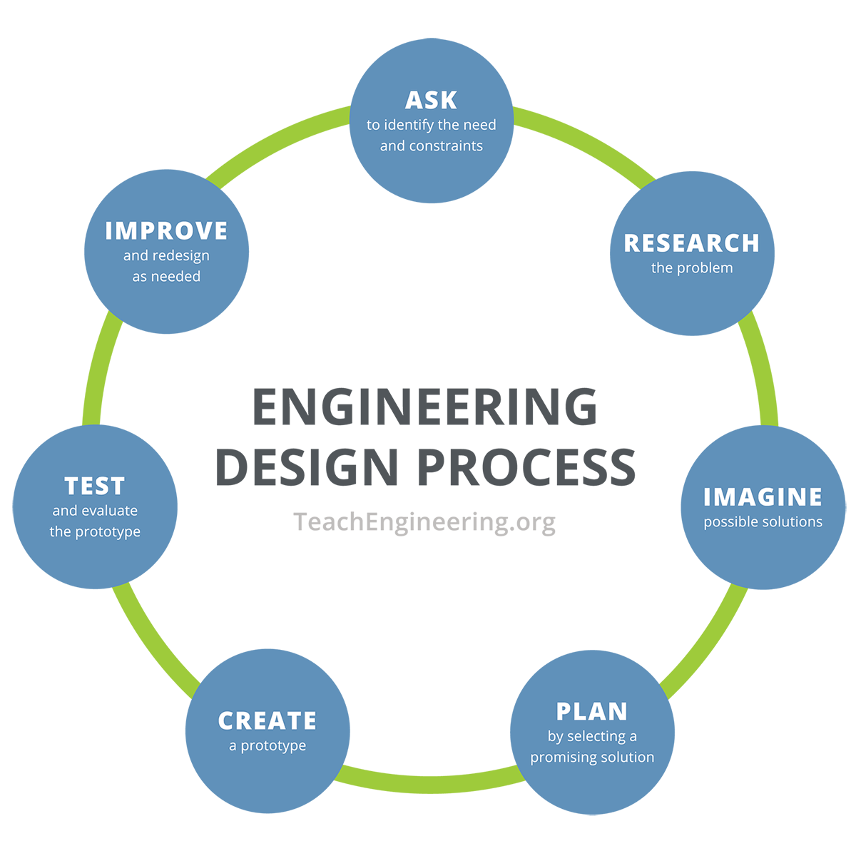
Ask | You will compare the efficiency of different wind turbine designs. Ask questions amongst your group. Write down questions your group has about wind turbines.
Research | Identify 3 different wind turbine designs. Why are engineers looking for new designs? Are different designs better for different areas? Which designs harvest the wind more efficiently? Is the cost to build design a variable?
Imagine | Now is your chance to brainstorm and share your ideas with your group. Write down all materials that you will need for your design.
Plan | Draw a working prototype of your turbine. What materials will you use? When you have finished your plan, get approval from your teacher to create.
Test | How much voltage was produced by your design?
Improve | What do you need to change? Do you need new or more materials? What will you do differently?
Exit Ticket: What are some of your assets that you used today?

Preguntar | Compararán la eficiencia de diferentes diseños de turbinas eólicas. Pregunten entre su grupo. Anoten las preguntas que su grupo tenga sobre las turbinas eólicas.
Investigar | Identificar 3 diseños diferentes de turbinas eólicas. ¿Por qué los ingenieros buscan nuevos diseños? ¿Son diferentes diseños mejores para diferentes áreas? ¿Cuáles diseños aprovechan más eficientemente el viento? ¿El costo de construir cada diseño es variable?
Imagina | Ahora es tu oportunidad para hacer una lluvia de ideas y compartir tus ideas con tu grupo. Anota todos los materiales que necesitarán para su diseño.
Planificar | Dibuja un prototipo funcional de tu molino de viento. ¿Qué materiales usarás? Cuando hayas terminado tu plan, obtén la aprobación de tu profesor(a) para crearlo.
Prueba | ¿Cuántos voltios produjo tu diseño de molino de viento?
Mejorar | ¿Qué necesitas cambiar? ¿Necesitas nuevos materiales o más materiales? ¿Qué harás de manera diferente?
Boleto de salida: ¿Cuáles son algunos de tus recursos que utilizaste hoy?
Preguntar (2) | ¿Qué funcionó bien con tu último diseño? ¿Qué preguntas tienes al respecto? Escríbelas.
Investigar (2) | Realiza una investigación sobre diseños similares al tuyo. ¿Encontraste algo que te ayude a mejorar?
Imagina (2) | Ahora es tu oportunidad para compartir y hacer una lluvia de ideas con tu grupo. Anota todos los materiales que necesitarás para tu diseño. ¿Necesitarás una impresora 3D para algunas de esas partes? ¿Cómo mejorará tu diseño?
Planificar (2) | Dibuja otro prototipo con todos los cambios que has realizado. Muestra este plan a tu maestro antes de realizar pruebas o conseguir más materiales.
Prueba (2) | ¿Cuánto voltaje produjo el segundo prototipo?
Mejorar (2) | ¿Qué necesitas cambiar? ¿Necesitas nuevos materiales o más materiales? ¿Qué harás de manera diferente?
Boleto de salida: ¿Cuáles son algunos de tus recursos que utilizaste hoy?

Ask (2) | What went well with your last design? What questions do you have about that? Write them down.
Research (2) | Do some research on designs similar to yours. Did you find anything that would help you improve?
Imagine (2) | Now is your chance to brainstorm and share your ideas with your group. Write down all materials that you will need for your design. Will you need a 3D printer for some of those parts? How will it improve your design?
Plan (2) | Draw another prototype with all the changes you have made. Show this plan to your teacher before you test or retrieve more materials.
Test (2) | Voltage produced by 2nd prototype?
Improve (2) | What do you need to change? Do you need new or more materials? What will you do differently?
Exit Ticket: What are some of your assets that you used today?
Name: _______________________________________________ Class/Date: ______________________
Your asset map should contain things that are your strengths and important to you. Please place each asset in its corresponding category.
Home | School | Work
Nombre: _______________________________________________ Clase/fecha: ______________________
Tu mapa debe de contener tus fortalezas y cosas que te importan. Por favor, coloque cada activo en su categoría correspondiente.
Casa | Escuela | Trabajo

