Week 5 | Topic: Using the Engineering Cycle for the Egg Drop Challenge
Lesson Topic: | Essential Question: How can we use the engineering cycle to create the most effective egg protection device?
Objective: | Students will be able to:  - Apply the engineering design process to create and optimize a solution for the egg drop challenge.  - Use a variety of materials and tools, including 3D printers, to construct solutions.  - Communicate their solutions and constraints to other students in order to collectively optimize solutions.
Standards Addressed: | SEEd Science and Engineering Practices  - Constructing explanations and designing solutions: Students construct explanations about the world and design solutions to problems using observations that are consistent with current evidence and scientific principles.  - Obtaining, evaluating, and communicating information: Students obtain, evaluate, and derive meaning from scientific information or presented evidence using appropriate scientific language. They communicate their findings clearly and persuasively in a variety of ways including written text, graphs, diagrams, charts, tables, or orally.  - Engaging in argument from evidence: Students support their best explanations with lines of reasoning.  - Planning and carrying out investigations: Students plan and conduct scientific investigations in order to test, revise, or develop explanations.  - Analyzing and interpreting data: Students analyze various types of data in order to create valid interpretations or to assess claims/conclusions.  - Using mathematics and computational thinking: Students use fundamental tools in science to compute relationships and interpret results.  - Constructing explanations and designing solutions: Students construct explanations about the world and design solutions to problems using observations that are consistent with current evidence and scientific principles.  SEEd Crosscutting Concepts  - Patterns: Students observe patterns to organize and classify factors that influence relationships.  SEEd Disciplinary Core Ideas  - (ETS1.A) Defining and Delimiting an Engineering Problem  - (ETS1.B) Developing Possible Solutions  - (ETS1.C) Optimizing the Design Solution  Engineering and Technology Strands and Standards  - Strand 4, Standard 1: Students will use critical thinking skills to plan and conduct research, manage projects, solve problems, and make informed decisions using appropriate digital tools and resources.
Vocabulary: | Engineering Design Process: A cyclical process that engineers use to solve problems. It begins by defining and identifying a problem, developing possible solutions, and optimizing and comparing solutions.  Fishbone Analysis: Using a fishbone diagram to identify the causes of a problem.  Constraints: Limitations on the design, such as available funds, resources, or time.  3D Printer: A printer that uses plastic filament and code in order to generate objects of all kinds of shapes and sizes.  Thingaverse: A website that creators upload 3D object code onto that can be downloaded and used to print.
Time Estimate: | 120-160 minutes
Prep: | Before the lesson:  - Briefly familiarize yourself with https://www.thingiverse.com/ and https://www.makerbot.com/3d-printers/cloudprint/. The first website is to find the file. The next website is to visualize how the object will look and to slice the file into something readable for the makerbots.  - It would also be good to know a little about 3D printers. All you need to know is that you must download the file from a website and upload it on the printer via USB or SSD. 3D printers use the code to decide how to create it. Filament is loaded into the extruder. The extruder head heats and melts the plastic. It orients the melted plastic in layers to produce a three-dimensional shape. The plastic cools and dries, producing the final product.  - Organize 3D printers and pens around the class in an intuitive manner. Ensure that they have filament.  - Organize other supplies in an intuitive manner so that it is easily accessible.  - Place tarps and other items for cleaning in a designated area for dropping eggs.  - Practice with a 3D pen and have it ready to demonstrate to students.
Materials: | Be sure to have:  - 3D printers (such as Makerbots)  - Filament for 3D printers  - Tape for Makerbots https://www.amazon.com/Gizmo-Dorks-Blue-Painters-Printers/dp/B00LAJNM7S  - Thingiverse website for 3D printing designs  - Makerbot cloud print website for 3D printing  - Bubble wrap  - Tape  - Cotton  - Cardboard  - Balloons  - Styrofoam  - 3D printing pens  - Tarps for the mess  - 1 hard boiled egg per student (probably have extra)  - 1 raw egg per student  - Garbage bags or other materials for cleanup  - Scissors  - Rulers or measuring tape  - Examples of 3D printed objects (this would be a good way to practice!)  - Intro to 3D printing ppt Introduction to 3d printers.pptx  - One fishbone analysis sheet per student  - Two egg drop design sheet per student
Modifications: | Alternatively:  - Since we are only trying to create a hands-on problem that can be addressed by the engineering cycle, there are many alternatives to this. Examples would include: wind turbines, catapults, bridge building, etc.
Assessment: | Fishbone Analysis  Egg Drop Design Sheet  Egg Drop Design Sheet #2  Exit tickets
Procedures: | Day One  Introduction  - Introduce the egg drop challenge. This could be done by specifying the height that the egg will be dropped from. You might model this by dropping an egg from a specified location (1 minute).  - Introduce the potential items that they have available in order to complete this task. Explain that they will start with a hardboiled egg at the height you specified, but we will build up from there (1 minute).  - As a class, identify the constraints that we will have for this project (only one egg to drop, only supplies that are present, the height of the drop, etc.) (3 minutes).  - Introduce the 3D printers as a potential tool they can use. Use the slides provided, or provide examples of your own. Keep the last slide of the engineering cycle up so that students can see it during the design process. Show them a quick demonstration of the 3D print pens. NOTE: Explain to students that 3D printing takes time and therefore they will not be able to use them for the first design (5 minutes).  Fishbone  - Hand out fishbone analysis sheet. Allow students to identify the causes of the problem that eggs will break when dropped without protection (5 minutes).  - Brainstorm as a class for potential solutions to the causes identified (5 minutes).  Design  - Pass out egg drop design sheet. Explain to students that they are to fill this out as they create their design (1 minute).  - Pass out all necessary materials (probably the eggs). Allow students to begin their construction. Encourage collaboration for this project (25 minutes).  Testing  - Allow students to test their egg drops as needed. Provide feedback based on results. This might include things that don’t necessarily pertain to if the egg survived (could you even tell if it was broken due to the wrapping?) (12 minutes).  - Have students complete exit tickets and collect all necessary materials. Tell them that next time they are going to be doing a raw egg from a greater height. (2 minutes).  - Homework: If students wish to start a 3D project for their next egg drop, they will need to do this in advance.  Day Two  - Have students refresh their memories by passing back their design papers or reflecting on how their initial egg drop went. What could they do to optimize their solution? (5 minutes).  - Remind students that they are to create an even better design to ensure that a raw egg survives (insert desired height here) (1 minute).  - Pass out the egg drop design sheet #2 and all necessary materials. Allow students to refine or remake their previous designs. Encourage collaboration and remind them to fill out their sheets as a part of the process (40 minutes).  - Test eggs from desired height. Provide feedback based on results (10 minutes).  - Allow students to complete exit tickets and cleanup (4 minutes).

Name: Period:
With your groups, please write headings of elements that contribute to the problem and then brainstorm a few ideas under each of these headings.
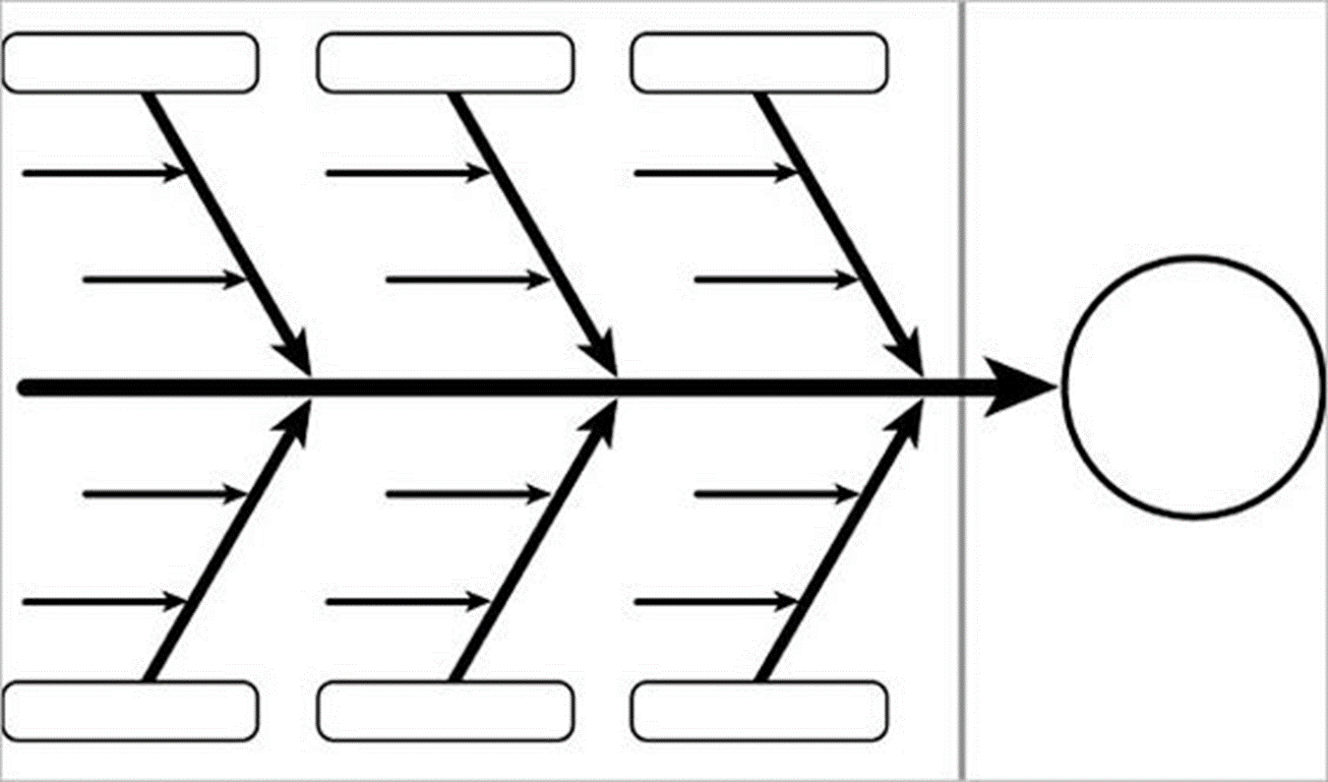
Exit Ticket: What are some of your assets that you used today?
Nombre: Período:
En sus grupos, escriban encabezados de elementos que contribuyan al problema y luego hagan una lluvia de ideas sobre algunas ideas bajo cada uno de estos títulos.

Name: Period:
Egg Drop Design
Materials used | Model of Design | Reasoning Behind the Design
Results |  | Ideas for Optimization

Exit Ticket: What are some of your assets that you used today?
Nombre: Período:
Diseño de gota de huevo
materiales utilizados | dibujo de Diseño | Razonamiento detrás del diseño
resultado |  | Ideas para la optimización

Ticket de salida: ¿Cuáles son algunas fortalezas que utilizaste hoy?
Name: Period:
Egg Drop Design #2
Materials used | Model of Design | Reasoning behind the changes you made from your original design
Results |  | Ideas for Optimization

Exit Ticket: What are some of your assets that you used today?
Nombre: Período:
Diseño de gota de huevo
materiales utilizados | dibujo de Diseño | Razonamiento detrás de los cambios que realizó desde su diseño original
resultado |  | Ideas para la optimización

Ticket de salida: ¿Cuáles son algunas fortalezas que utilizaste hoy?

