Week 1 | Topic: Introduction to Engineering and Asset Mapping
Lesson Topic: | Essential Question: What is the engineering cycle and how can we use our assets in the engineering cycle?
Objective: | Students will be able to:  - Evaluate and identify strengths and assets that they possess and how it relates to being an engineer.  - Recognize inequities and biases in their communities and school.  - Describe the engineering cycle and apply it to community problems.
Standards Addressed: | SEEd Disciplinary Core Ideas  - ETSA1.A: Defining and Delimiting an Engineering Problem  LIA Pillar  - Personal Assets: All LIA students identify and leverage their cultural, social, and personal assets.  Engineering and Technology Strands and Standards  - Strand 6, Standard 5: Students will recognize the importance of both hard and soft skills in the workplace.
Vocabulary: | Asset: In this context, an asset is a characteristic that a person has that allows them to solve problems or propagate their own values into the world. What makes you, you?  Engineering: The application of science, math, and technology to solve problems. This should be thought of outside the context of simply “building bridges”. This definition includes solving problems of all kinds.  Transforming Engineering Cycle: A cyclical process that engineers use to solve problems. It begins by defining and identifying a problem, developing possible solutions, and optimizing and comparing solutions.
Time Estimate: | 60-80 minutes
Prep: | Before the lesson:  - Create an asset map that you have created. This asset map should be somewhat personal and demonstrates your own skills, competencies, accomplishments, and how these can be used in future projects to better yourself and your community. There are many ways that you can draw this out, but here is an example: https://catherinedenial.org/blog/uncategorized/human-asset-maps-encouraging-social-justice-work-in-my-students/
Materials: | Be sure to have:  - Your asset map  - Asset map templates (one per student)  - Fishbone analysis templates (one per student)  - Draw an Engineer sheet (one per student)  - Markers, pens, colored pencils.  - Premade PPT we have available (feel free to edit this or make your own).
Modifications: | Alternatively:  - If you would like to avoid drawing the engineering, a fun alternative would be to create a “spot the engineer” kahoot. Identifying potential biases would be essentially the same.  - Depending on your class length, you might lengthen the time students have to work on their asset maps. IntroPPTLIA.TH.pptm
Assessment: | Asset Map  Fishbone Analysis  Draw an Engineer Paper
Procedures: | Assets  - Introduce assets by a simple definition. This is important for the rest of the entire curriculum, so take your time in defining it. Define it as a personal/community set of skills and values that you can use to solve problems. What makes you, you? What are some things that you are good at? What kinds of things from your culture could be considered an asset? We split these assets into domains based on locations: school, home, and work. In other words, what assets do they use at work? At school? Students struggle to identify more subtle assets, such as perseverance, so highlight them by showing them your own asset map. Remember to consider their cultural backgrounds as well, such as being bilingual (5 minutes). If you are following along, this would be slide 1 and 2.  - Have students briefly brainstorm their own assets with a think, pair, and share activity. It could be powerful for you to bring up some of the assets you’ve noticed in students if they are quiet (5 minutes).  - Pass out asset maps and allow students to create their own asset maps. Encourage group communication, as this might be harder for some students (15 minutes).  - Have students share what they put on their asset map as a class (1 minute).  Engineering and Community  - Pass out the draw an engineer paper. Tell students to use the space to illustrate an engineer at work (2 minutes).  - Have students discuss what they illustrated (1 minute).  - Use this as an opportunity to discuss two things. First, many students probably illustrated more conventional engineers. Show them other more unconventional engineering examples presented (e.g. fashion engineers, food engineers, sports engineers, etc.). Second, introduce the concept of bias. Students probably illustrated white males doing engineering. Discuss what biases they see in the school. Discuss the potential barriers that limit assets for BIPOC and gender minorities in the field of engineering. Language barriers can serve as an excellent substrate for this (10 minutes). These would be slides 3 and 4.  - Introduce the concept of the engineering process. Using the template provided, discuss how it is a cycle that begins by identifying a problem. One way of doing this is by using a fishbone analysis. Tell students that they are to identify aspects of a problem in order to get to the next step of designing a prototype. Remind them that we will use these in a variety of projects, so practice well (5 minutes). These would be slides 5 and 6.  - Pass out fishbone analysis template and ask students to identify an issue that exists in their school or community. If students are having trouble, we often hear about language barriers as a major issue. Encourage discussion (15 minutes).  - Collect all necessary materials. Keep the asset maps for later use (1 minute).

Name: _______________________________________________ Class/Date: ______________________
Your asset map should contain things that are your strengths and important to you. Please place each asset in its corresponding category.
Home | School | Work
Nombre: _______________________________________________ Clase/fecha: ______________________
Tu mapa debe de contener tus fortalezas y cosas que te importan. Por favor, coloque cada activo en su categoría correspondiente.
Casa | Escuela | Trabajo

Name: Period:
Using the space below, draw an engineer doing work. Please be as detailed as possible.

Nombre: Período:
Usando el espacio de abajo, dibuja a un ingeniero haciendo un trabajo. Sea lo más detallado posible.

Name: Periodo:
With your groups, please write headings of elements that contribute to the problem and then brainstorm a few ideas under each of these headings.
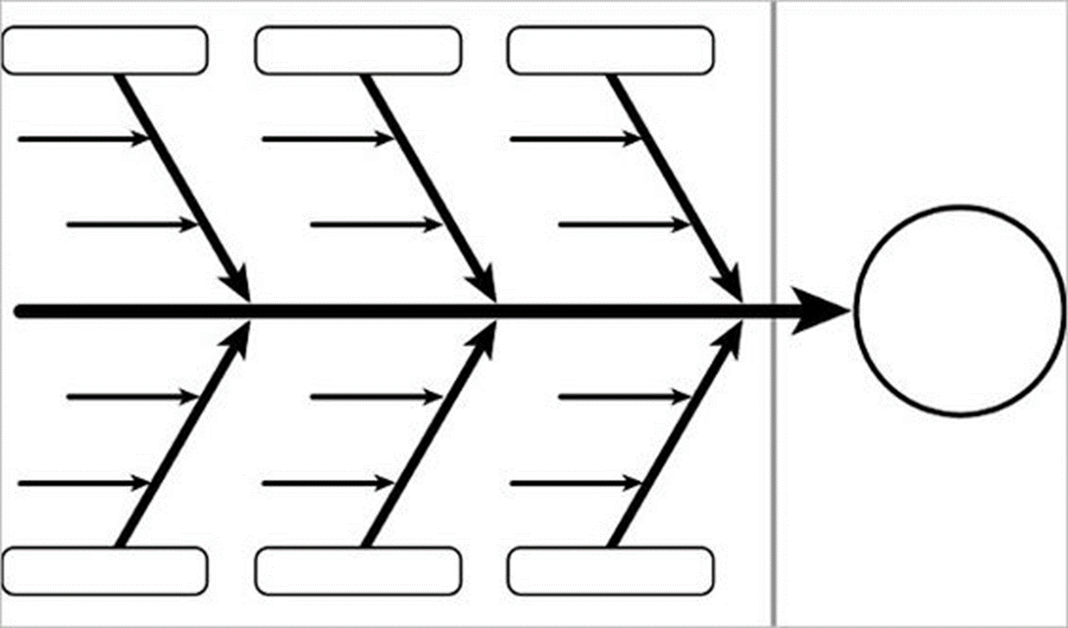
Nombre: Período:
En sus grupos, escriban encabezados de elementos que contribuyan al problema y luego hagan una lluvia de ideas sobre algunas ideas bajo cada uno de estos títulos.

