THE EFFECTS OF HIGH-TECH STIMULI AND DURATION OF ACCESS

ON REINFORCER PREFERENCE AND EFFICACY

by

Audrey N. Hoffmann

A thesis submitted in partial fulfillment of
the requirements for the degree

of

MASTER OF SCIENCE

in

Special Education

Approved:

Robert Morgan, Ph.D. Andrew Samaha, Ph.D.
Major Professor Committee Member

Sarah Bloom, Ph.D. Benjamin Lignugaris/Kraft, Ph.D.
Committee Member Committee Member

________________________________
Mark R. McLellan, PhD.
Vice President for Research and
Dean of the School of Graduate Studies

UTAH STATE UNIVERSITY
Logan, Utah

2014
Copyright © Audrey Hoffmann 2014

All Rights Reserved
ABSTRACT

The Effects of High-Tech Stimuli and Duration of Access on Reinforcer

Preference and Efficacy

by

Audrey Nelson Hoffmann, Master of Science

Utah State University, 2014

Major Professor: Dr. Andrew L. Samaha
Department: Special Education and Rehabilitation

Two dimensions of reinforcement that influence behavior are reinforcer magnitude and stimulus type. One type of stimulus involving high technology (i.e., high-tech stimuli) has not been examined to determine reinforcement properties. This project examined the interactions of reinforcer magnitude and high-tech stimuli and the effects of those interactions on preference and reinforcer efficacy. Participants included three adult individuals with disabilities. Two multiple stimulus without replacement (MSWO) preference assessments were conducted to determine a highly preferred high-tech stimulus and a highly preferred no-tech stimulus for each participant. A paired stimulus preference assessment was conducted to identify preferred reinforcer magnitudes using both highly preferred stimuli (high- and no-tech). A progressive ratio (PR) reinforcer assessment was then conducted to assess the effects of stimulus type and reinforcer magnitude on reinforcer efficacy. Results demonstrated a preference for high-tech stimuli at longer durations of access for two participants. Results also demonstrated participants responded more for high-tech stimuli as reinforcer magnitudes were increased, and responded less for no-tech stimuli as reinforcer magnitudes were increased (measured as total number of responses during the PR assessments). These results provide further evidence of the effects of reinforcer magnitude and stimulus type (high-tech stimuli) on preference and reinforcer efficacy and have implications for clinicians and caregivers using high- and no-tech items as reinforcers.
(62 pages)

PUBLIC ABSTRACT

The Effects of High-Tech Stimuli and Duration of Access on Reinforcer

Preference and Efficacy

by

Audrey Nelson Hoffmann, Master of Science

Utah State University, 2014

Reinforcement is commonly used to increase individuals engaging in certain behaviors. We can alter the value of the reinforcers by manipulating how long they get access to the reinforcer (i.e., magnitude) or by varying the type of reinforcer we use. The use of high technology items (i.e., high-tech) as a reinforcer has not been examined. We examined the interaction between high- and no-tech items and duration of access and the effects of that interaction on reinforcer preference and efficacy (i.e., how effective the reinforcer is in increasing behavior) in three individuals with disabilities. We conducted two preference assessments to identify a highly preferred high-tech and no-tech item. Then, we assessed how long participants liked to have access to the high-tech and no-tech items. Finally, we conducted another assessment to determine how much work participants would engage in to gain access to the high-tech and no-tech items depending on the duration of access. Results demonstrated that two participants preferred the high-tech item for longer durations. Results also demonstrated that participants worked more to earn the high-tech item for longer duration and worked less to earn the no-tech item for longer durations. These results provide further evidence that how long an individual is provided access to certain items affects the value of those items as reinforcers. These results have implications for caregivers and clinicians using high- and no-tech items as reinforcers.

CONTENTS

Page

ABSTRACT iii

PUBLIC ABSTRACT v

LIST OF TABLES

CHAPTER

I. INTRODUCTION 1

Literature Review 7
Summary and Purpose 15

II. METHOD 17

Participants and Setting 17
Dependent Variables 18
Phase I 18
Phase II 21
Phase III 24
Data Analysis 27

III. RESULTS 29

Phase I 29
Phase II 32
Phase III 32

IV. DISCUSSION 43

REFERENCES 51

APPENDIX 53

LIST OF TABLES

Table Page

1. List of High- and No-Tech Stimuli Used During Phase I 20

2. List of Combinations Presented During Phase II Paired Stimulus
Preference Assessment 24

LIST OF FIGURES

Figure Page

1. High-tech and no-tech MSWO results from Phase I 30

2. Data on percentage of selection per equated stimuli 31

3. Data on percentage of selections during Phase II paired stimulus preference
assessment 33

4. Paired stimulus preference assessment results depicting results per
combination of items and durations presented 34

5. Progressive ratio reinforcer assessment results depicting total number of
responses per session 36

6. Data depicting the results of the progressive ratio reinforcer assessment 37

7. Data depicting break points for each participant during the progressive
ratio reinforcer assessment plotted as a function of reinforcer access
duration 38

8. Data depicting total number of responses per session across both high- and
no-tech conditions 40

9. Data depicting rate of responding for each participant during the initial B
and C phases and the replication B and C phases 42

CHAPTER I

INTRODUCTION

Several dimensions of reinforcement have been examined and shown to influence responding (Trosclair-Lasserre, Lerman, Call, Addison, & Kodak, 2008). One dimension of reinforcement that may influence responding is reinforcer magnitude, which can refer to the amount of stimuli provided as reinforcement (Hoch, McComas, Johnson, Faranda, & Guether, 2002). For items like food, reinforcer magnitude can be manipulated by providing more or less, following the occurrence of behavior. Reinforcer magnitude can also be referred to as duration of access time. For items like toys, activities, or videos, reinforcer magnitude can be manipulated by providing shorter or longer durations of access. Another dimension of reinforcement that influences responding is quality, defined by Hoch and colleagues as the reliable ranking of stimuli as identified using preference assessments. More simply, quality of reinforcement can be conceptualized as preference.
Both quality and magnitude affect the reinforcing properties of stimuli and influence responding (Hoch et al., 2002). It is possible that stimulus type also affects preference as it relates to quality and preference differentially at various reinforcer magnitudes. For example, if an individual has a longer learning history with a particular class of stimuli, the individual may be more likely to prefer similar stimuli. An individual may also prefer longer periods of access with certain stimuli that take longer to produce reinforcing effects; perhaps the individual has a history of accessing these stimuli for long durations.
One type of stimuli that warrants an examination of the effects of magnitude and quality is high-tech stimuli. High-tech stimuli are defined as stimuli that require batteries or electricity, often utilize highly sophisticated multifunction computer components, include a computer and associated software, and are conceptualized as sophisticated technological devices (Behrmann & Jerome, 2002). High-tech items may include personal gaming devices, personal music devices, laptop computers, tablet computers, and personal movie players. In contrast, no-tech items do not require batteries or electricity and may include toys such as stuffed animals, puzzles, books, play dough, cars, and so forth.
When speaking of high-tech stimuli, one can conceptualize all stimuli on a continuum of technology level. At one end of the continuum are high-tech items using sophisticated computer components, while on the other end of the continuum are no-tech stimuli that do not include technological components. There may be items that fall somewhere in the center of this continuum such as a musical baby toy, or a talking teddy bear. One may question if such items should be considered high-tech or not. For the purposes of this study, I am interested in comparing stimuli falling at the opposite far ends of the continuum. For example, items like tablet computers can clearly be considered high-tech items and items like traditional stuffed animals can clearly be categorized as no-tech items. Recognizing that there are items more difficult to categorize as high-tech or no-tech, I am concerned with those items at the ends of the continuum that may be easier to classify.
In the last 20 years, use of high-tech items has increased dramatically. For example, researchers found that 90% American adults adults own a cell phone (58% smartphones), 78% have a laptop computer, and 32% of adults own e-book readers and 42% own a tablet computer (Pew Research Internet Project, 2014). Research is limited and often outdated on prevalence of personal electronic device use in the specific population of individuals with intellectual and developmental disabilities. Bouck, Okolo, and Courtad (2007) examined technology use by children with disabilities in the home and reported that children with disabilities use technology outside of school hours a substantial amount of time. The authors attributed this increased use of high-tech items to increased availability of increasingly sophisticated and lower-cost technologies. There is little research that addresses the pattern of use of electronic technologies by individuals with intellectual disabilities (Carey, Friedman, & Bryen, 2005). In a systematic review of literature, Kagohara and colleagues (2013) identified only 15 studies that specifically examined the use of iPods and iPad-like technology in teaching individuals with developmental disabilities. Their review highlights the limited amount of research being conducted on technological device-use and individuals with disabilities. Despite limited research, or gaps in existing research (Carey et al., 2005) one can assume that high-tech use among individuals with intellectual and developmental disabilities has risen similarly to the increases in use seen in the general population. Given the rapid increase in the use of high-tech items and the relative dearth of empirical evidence as to their effectiveness as reinforcers compared to more conventional stimuli, research is needed to elucidate their relative reinforcing efficacy and the factors that influence said efficacy.
Research in the specific population of individuals with disabilities also is needed to ensure that this population is being afforded the same opportunities as their typically developing peers. Use of high-tech stimuli in typically developing individuals is likely having an effect on individuals and on society. For example, high-tech stimuli are present in classrooms, vehicles, stores, restaurants, and homes: virtually everywhere. These types of stimuli are also likely having an effect on individuals with disabilities, and more research is needed as to specifically how high-tech stimuli influence various aspects of daily living for individuals with disabilities. Moreover, research is needed to evaluate whether the effects of high-tech stimuli on people with disabilities are the same as with typical individuals. One place to begin this research is to evaluate the effects of high-tech stimuli on preference. Research is also needed as to the extent that high-tech items interact with dimensions of reinforcement to influence responding.
High-tech items vary from other items in many ways, including the duration of time that high-tech items are typically used. It may be that many high-tech items are typically used and preferred for longer periods of time then some no-tech items. For example, a game is played for extended amounts of time on a tablet computer, an entire song is listened to on an MP3 device, or a video is watched on a personal video player. This interaction between duration of access and preference may have important implications for parents and caregivers of individuals with disabilities. If a student or child with a disability is provided a high-tech item for reinforcement, it is important that the item is provided for a preferable amount of time so as not to diminish its relative reinforcing efficacy. For example, if a child uses an iPad at home for long periods of time and prefers the iPad over all other items, it would be important that a teacher at school provide the iPad as reinforcement for a similar amount of time. Giving the child access to the iPad for 30 seconds probably would not be very reinforcing; however, providing the iPad for 5 minutes may be a more optimal situation.
Currently there is little research on why individuals may tend to prefer high-tech stimuli over no-tech stimuli. There are theories that may begin to explain why individuals tend to prefer high-tech stimuli. The most relevant theory to the field of applied behavior analysis and the purposes of this research draws from the experimental analysis of behavior. The theory of habituation predicts conditions under which changes in operant responding will occur within session as a function of repeated exposure to the same reinforcer (Murphy, McSweeney, Smith, & McComas, 2003). An example of habituation would be if a participant’s responding within session decreased over time as reinforcers were presented repeatedly in the exact same manner.
Conversely responding within session may be affected by sensitization and dishabituation. Although within-session changes are often described in terms of motivating operations like satiation, the framework of habituation can also account for temporary increases in responding observed when reinforcers are not presented in a repetitive, similar manner as is the case when habituation is observed. Dishabituation effects have been observed in a variety of research studies under a variety of conditions. For example, when reinforcers were presented in a variable manner (Broster & Rankin, 1994), such as providing varying magnitudes of reinforcement, dishabituation effects were observed. McSweeney, Kowal, Murphy, and Weidiger (2005) found that when new and arbitrary stimuli were presented in the same or even different modalities during sessions, dishabituation effects were observed. Also, researchers have examined dishabituation in relation to reinforcer magnitudes being altered (Weatherly, McSweeney, & Swindell, 2004),and when new reinforcers are used (McSweeney & Roll, 1998).
This theory may help explain anecdotal observations that many individuals prefer high-tech stimuli. High-tech stimuli are often more complex in nature than no-tech stimuli. High-tech items often produce response-dependent and response-independent changes in audible, visual, and tactile modalities (e.g., animation, sound, vibration, etc.). From the perspective of the above framework, the dynamic nature of high-tech stimuli may induce sensitization or dishabituation-like effects. That is, varying an item’s emission of light, movement and sound may produce effects that counteract the more typical pattern of habituation that leads to within-session decreases in operant responding.
Perhaps because the nature of high-tech stimuli is variable and ever-changing, humans prefer high-tech stimuli over no-tech stimuli. Using the theory of habituation-desensitization to conceptualize the differences between high-tech and no-tech stimuli, one could postulate that more complex high-tech stimuli are more preferred for longer periods of time than no-tech stimuli. Just as changing and varied reinforcement within sessions leads to sensitization and dishabituation, repeated similar reinforcement within sessions may lead to habituation and decreased responding. One may hypothesize that stimuli that are highly preferred may be more resistant to habituation and stimuli that are less preferred may be less resistant and therefore more likely to result in habituation and a decrease in responding. The lack of research answering why high-tech stimuli often seem more preferred than no-tech stimuli provides another impetus to research high-tech stimuli and preference.
Thus, it would be important to evaluate differences in preference for high-tech items versus no-tech items, and the differences in reinforcer efficacy between high-tech and no-tech items depending on the duration of access time, short versus long.

Literature Review

In researching preference, reinforcer magnitude, and stimulus type, I conducted a search of the literature to identify relevant studies. I searched ERIC, Psych Info, Academic Search Premier, Education Full Text (H.W. Wilson), and Psychology and Behavioral Sciences collections. Using the search terms, “reinforce,” “magnitude,”” technology,” ”behavior,” “stimuli,” and “high-tech,” or combinations of these terms, the search yielded 96 possible articles. I reviewed these articles and narrowed the selections down by identifying relevant features of the research. I then narrowed the articles down to 19 of the most relevant to this particular line of research and chose the most relevant articles for further review.
Hoch and colleagues (2002) examined the effects of duration of access time and quality of reinforcement on choice responding. Although choice responding is not relevant to the current study, their evaluation of the effects of reinforcer magnitude and preference is relevant and provides evidence of the effects of these variables on responding.
The authors attempted to bias choice responding in children with autism toward playing in an area with a peer versus playing alone by manipulating dimensions of reinforcement. Three boys with autism (ages 9, 10, and 11) participated in sessions conducted in school settings. For each participant, highly preferred and low preferred items were identified. Response allocation was the primary dependent variable.
Each participant was exposed to a different set of manipulations in different experiments. Experiment one manipulated reinforcer magnitude. A choice of play area was presented with identical highly preferred toys located in each play area and a peer in one area. During an equal magnitude evaluation, participants could choose between two play areas that included the same highly-preferred toys with 50-s access. The location of the peer was counterbalanced across sessions. In the unequal magnitude evaluation, if the participant chose the play area where the peer was located, they received 90-s access to the highly preferred toy, but the area without the peer resulted in only 10-s access.
Experiment two manipulated quality of reinforcement. During experiment two, a peer was located in one area and the highly preferred toy or the low preferred toy was located in either play area. In the unequal quality condition, the participant was given choice of either the highly preferred stimulus or the low-preferred stimulus for 50-s access. In the unpaired condition, the location of the peer was counterbalanced across sessions, and in the unequal quality paired condition, the location of the peer was paired with the highly preferred stimulus. During the equal quality low condition, both areas contained identical low-preferred stimuli and 50-s access. During the equal quality high condition, both areas contained identical highly preferred stimuli and 50-s access.
During experiment three, one toy was located in each area and a peer was located in one area. During the equal quality and magnitude condition both areas contained identical highly preferred stimuli with 50-s access upon selection (the location of the peer was counterbalanced). During the unequal magnitude condition, the location of the peer was counterbalanced and the choice of the area with the peer resulted in 120-s access to a highly preferred stimuli for the first three sessions, and 90-s access in following sessions. Choice of the area that did not include the peer resulted in 20-s access in the first three sessions, and 10-s access in following sessions. In the unequal quality condition, choice of the play area with the highly preferred stimuli and the peer resulted in 50-s access and choice of the area with the less preferred stimuli without the peer produced 50-s access. The location of the peer was counterbalanced.
Results demonstrated that by manipulating the quality of stimuli and the duration of access time, the researchers were able to influence choice responding. The participants were more likely to choose the play area associated with higher quality stimuli and longer durations of access, even if the area contained a peer. This research demonstrates the effects of preference and duration of access time on responding. The study also demonstrated that manipulating preference and duration of access time can influence responding.
Trosclair-Laserre and colleagues (2008) also investigated reinforcer magnitude and preference. They looked at the effects of reinforcer magnitude on preference and reinforcer efficacy, rather than manipulations of these dimensions on responding as Hoch and colleagues (2002) did. Three participants (ages 5, 11, and 5) with problem behavior took part in a concurrent-operants preference assessment followed by a progressive ratio (PR) schedule reinforcer assessment. The experiments took place in three different settings: a university program room, a day care, and a school setting. Prior to the preference and reinforcer assessments, a functional analysis (Iwata, Dorsey, Slifer, Bauman, & Richman, 1982/1994) was conducted to determine the function of each participant’s behavior.
During the magnitude preference assessment, data were collected on duration of reinforcer delivery, and the number of times each magnitude was presented and selected by participants. Participants selected a magnitude by touching the associated stimulus for each magnitude. Participants took part in three phases of discrimination training prior to the magnitude preference assessment to teach them the stimuli that correlated with each differing magnitude. Colored cards were used as stimuli for two participants, and a white card with numbers was used as the stimulus for the other participant.
Following discrimination training, the authors evaluated preference for three different magnitude values: large, small, or no reinforcement. Sessions consisted of five free-choice, concurrent-operant trials where participants were prompted to choose a stimulus if they wanted. When the participant selected the card associated with the large or small magnitude of reinforcement, they received access to the reinforcer for that duration. If the participant chose the no-reinforcement card, they did not receive reinforcement. Trials continued until a clear preference was shown between the differing magnitudes and no reinforcement. When participants preferred the higher magnitude, the researchers systematically increased the small magnitude until they reached a value where no preference was shown. Researchers identified preferred magnitude values as well as non-preferred magnitude values for each participant for subsequent use in the reinforcer assessment. Three participants showed preference for the longer duration of reinforcement. One participant did not demonstrate a preference for either the long or short durations, but showed similar preference for both when compared to no reinforcement.
Trosclair-Laserre and colleagues (2008) hypothesized that when participants preferred a specific duration of access time, reinforcers delivered for that duration would increase responding more than reinforcers delivered at nonpreferred durations. Following the magnitude preference assessment, they conducted a magnitude reinforcer assessment to test this hypothesis. During the reinforcer assessment data were collected on the duration of reinforcer delivery, as well as on the cumulative number of responses emitted for each magnitude.
For each participant, researchers used a PR reinforcer assessment to assess the efficacy of three different magnitudes. The PR reinforcer assessment was based on procedures described by Roane, Lerman, and Vorndran (2001). Stimulus cards in the preference assessment were used in the reinforcer assessment to aid in discrimination.
Researchers taught participants a target response, chip insertion or button-pressing, during training procedures. Participants were trained using graduated prompting and received 20 s of reinforcement contingent upon the target response.
During baseline, no consequences were provided for the participants engaging in the target response. Baseline sessions were terminated after the participant did not engage in the target response for 5 min or the duration of the session reached 60 min. During the reinforcement sessions, access to reinforcement was provided contingent on the completion of a programed, increasing number of target responses. Within each session, a PR schedule of reinforcement was used. Following the completion of a schedule requirement, the number of responses increased for the next schedule requirement. After a session was completed, the schedule requirement was reset at the lowest requirement for the beginning of the next session. The authors exposed each participant to each schedule requirement twice. Nonpreferred durations were compared to preferred durations using a single-operant multielement design including baseline sessions.
Results from the reinforcer assessment found that three participants showed greater response persistence for the largest magnitude. One participant provided mixed results. During the preference assessment, the latter participant responded more for some reinforcement compared to none, but she did not show clear preference for the larger duration as other participants did. During the reinforcer assessment, this same participants’ results suggested that the chosen reinforcer maintained responding, but only during low schedule requirements.
The results showed that preference for different magnitudes may be predictive of relative reinforcer efficacy. The results also extend research by demonstrating that different magnitudes of reinforcement influence responding. Authors recommend that further research be conducted on magnitude effects and with other sources of reinforcement. It is important to note that, although the authors examined the effects of reinforcer magnitude on preference and potency, they did not examine the effects of stimulus type on these variables.
Trosclaire-Laserre and colleagues (2007) used a PR reinforcer assessment to assess the efficacy of the different magnitudes of reinforcement. The methods employed by Trosclaire-Laserre and colleagues were based on PR assessment methods from Roane and colleagues (2001). Roane and colleagues identified the PR reinforcer assessment as an effective way to characterize the value of different reinforcers. PR assessments involve increasing response requirements within an experimental session. The last schedule value the participant completes is identified as the break point. Using the break points of different stimuli, researchers can compare and evaluate responding and reinforcing efficacy for different stimuli (Glover, Roane, Kadey, & Grow, 2008).
Similar to Trosclair-Laserre and colleagues (2007), Steinhilber and Johnson (2007) examined the effects of duration of access time on preference. They examined the effects of brief and extended availability of stimuli (reinforcer magnitude) on preference using a multiple stimulus without replacement (MSWO) format. They conducted two different experiments with each of their two participants: a preference assessment and a reinforcer assessment using a concurrent chains procedure. During the first phase, they conducted two preference assessments within a multielement design with multiple repetitions of each preference assessment for each participant. The MSWO-short preference assessment assessed preference for items available for 15 s and the MSWO-long preference assessment assessed preference for items available for 15 min. Items were presented to the participant in an array and the participant was prompted to choose an item. Following the participant’s selection, they were given access to the chosen item for the specified duration (15 s or 15 min). Data were collected on item selection, and the data were analyzed to create preference hierarchies based on selections within each respective preference assessment. The authors used preference assessment procedures described by DeLeon and Iwata (1996). The two preference assessments identified a short high-preferred stimulus (SHP) and a long high-preferred stimulus (LHP) for use in the second experiment.
Following the initial preference assessments, the authors conducted a second phase that consisted of a concurrent chains reinforcer assessment. Six experimental conditions were generated using the SHP and LHP stimuli identified in Phase I and differing durations or access time, short (S) versus long (L). The combinations of durations and stimuli they assessed during the reinforcer assessment were: SHP-S versus LHP-S, SHP-L versus LHP-L, SHP-L versus SHP-S, LHP-L versus LHP-S, and LHP-S versus SHP-L, and LHP-L and SHP-S.
Prior to each experimental session, presession training was conducted to ensure participants could state the associated contingencies. Participants were presented with math worksheets, and following the completion of all nine math problems, reinforcement was provided. To avoid satiation effects, sessions consisted of one to three trials. If participants chose the same initial link for three consecutive trials, they would move on to the next condition.
Results of the reinforcer assessment confirmed predictions based on the MSWO-long results. Both participants preferred the LHP items over the SHP items when the duration of access was longer. The SHP item was preferred over the LHP item with the duration of access was shorter. Participants also preferred the LHP item for longer duration than for shorter duration and the SHP for shorter durations.
The authors discussed the results in a way relevant to the current investigation. They conceptualized that the duration of stimulus access may function as a motivating operation that affects the momentary preference for a stimulus (Steinhilber & Johnson, 2007, p. 770). They further reasoned that the properties that make a stimulus reinforcing to an individual may be abolished or established depending on the amount of access time the individual is granted. This is relevant to high-tech items that are generally used for longer durations of time. For example, a high-tech item that is consistently accessed for long durations may be highly preferred at longer durations, but when provided for short durations, the item may not be considered a high-quality reinforcer.

Summary and Purpose

These studies each examined reinforcer magnitude, preference, and/or reinforcer efficacy in differing ways. Although all of the reviewed research contained relevant findings, none of the studies investigated the effects of stimulus type on preference, duration of access time, or reinforcer efficacy. No studies were found in the literature that have examined the effects of high-tech stimuli on preference and reinforcer potency. Research is needed relating to evaluating the differences in preference for high-tech items versus no-tech items, and the differences in reinforcer efficacy between high-tech preferred stimuli and no-tech preferred stimuli dependent upon the duration of access time, short versus long. Thus, the purpose of the current study is to extend research on reinforcer magnitude and preference by examining the interaction between duration of access and stimulus type, specifically high-tech items, and the effects of this interaction on reinforcer preference and efficacy. This study sought to answer the following research questions: (a) how does stimulus type (defined as high-tech or no-tech stimuli) interact with duration of access to influence preference and (b) how does stimulus type (defined as high-tech or no-tech stimuli) interact with duration of access to influence reinforcer efficacy?

CHAPTER II

METHOD

Participants and Setting

Participants were recruited through a sheltered workshop day program. The day program coordinator contacted the participant’s caregivers and gained permission for them to work with me. I conducted a caregiver interview with each participant’s caregiver to determine if they were eligible to participate in the study (see the Appendix for a copy of interview questions). Participants were included given they had a history of using high- and no-tech items, and they did not have significant problem behavior that would inhibit participation. Participants were three individuals with developmental or intellectual disabilities. All diagnoses and information on functioning was based solely on caregiver interviews. Rhonda was a 27-year-old female diagnosed with a developmental delay. She was vocal and functioned at an 8- TO 10-year-old cognitive level. Angie was a 31-year-old female diagnosed with a developmental disability with low vocal ability and a functioning level of an elementary-aged child. Karma was a 21-year-old female diagnosed with Down syndrome. She was vocal and functioned at a first-grade cognitive level. Based on caregiver interviews, each participant had a history of interaction with both high- and no-tech items. Caregivers also reported that participants did not engage in problem behavior that would exclude them from participating in this study. Participants attended a sheltered workshop day program for six hours per day. All sessions were conducted at one of two day-program locations. Sessions were conducted in small rooms with participants and therapists seated at a table.

Dependent Variables

Preference for reinforcer magnitude
This is defined as preferred items at specific duration of access time identified through paired stimulus preference assessment.

Reinforcer Efficacy
This is defined as number of responses per magnitude value, rate of responding per magnitude level, and break points per magnitude level.

Phase I

Stimulus Type Preference Assessment
The purpose of this phase was to identify a highly preferred high-tech item and a highly preferred no-tech item for use in subsequent phases. I conducted two MSWO preference assessments.
Response measurement. Data collectors using pencil and paper, recorded when a stimulus was chosen and when stimuli were available for choosing. Preference hierarchies were identified using percentage of opportunities a stimulus was chosen. The number of opportunities a stimulus was chosen was divided by the total number of opportunities the stimulus was presented for choosing and multiplied by 100 to create a percentage.
Interobserver agreement. A second data collector simultaneously collected data during 50% of preference assessment sessions for purposes of interobserver agreement. All data collectors took part in training modules to ensure accurate data collection. Each data collector was required to obtain accuracy scores at or above 80% on the training modules prior to collecting actual data.
Interobserver reliability was calculated by dividing the number of agreements by the number of disagreements plus agreements, and multiplying by 100 to yield a percentage. The average agreement was 100%.

Materials
Seven items were used in the high-tech preference assessment and seven items in the no-tech preference assessment. Examples of high-tech stimuli include a tablet computer, MP3 device, personal video player, cell phone, personal gaming device, mini tablet computer, or e-reader device. Examples of no-tech stimuli include an Etch A Sketch®, cars, dolls, Lego® blocks, a board game, or books. I attempted to equate the stimuli across stimulus type so that each array of seven items had similarities. For example, if the gaming device had the game TetrisTM in the high-tech preference assessment, I provided LegoTM blocks as a choice during the no-tech preference assessment (both high- and no-tech stimuli presented content involving manipulating and stacking blocks). The high-tech and no-tech stimuli shared common properties across preference assessments. Other examples of content-matched stimuli used in each preference assessment were (a) eReader device in the high-tech assessment and books in the no-tech assessment, (b) personal movie player showing movie in the high-tech assessment and a doll of a character from the film in the no-tech assessment. Table 1.
Table 1

List of High- and No-Tech Stimuli Used During Phase I

High-tech stimuli | No-tech stimuli | Similarities
1. DVD Player  Disney© DVDs:  High School Musical  Brave  Cars | 1. Toys  Mattel® High School Musical dolls  Mattel® Brave Merida doll  Racecar | 1. Character content of toys matched characters in the movie
2. Nintendo DSTM: Tetris®  Nintendo DSTM: MarioKartTM | 2. Lego® blocks  Assorted Cars | 2. Building and manipulating blocks or racing and driving cars
3. Apple iPod touch®, pink case | 3. Mini pink  Etch A Sketch® | 3. Rectangular shape, color pink, movement across a screen
4. KindleTM eReader | 4. Assorted books | 4. Text and pictures
5. Mp3 player | 5. Musical instruments | 5. Auditory stimuli
6. Camera | 6. View-Master® | 6. Visual access to pictures
7. Apple iPad miniTM | 7. Box of games | 7. Variety of games and activities

Lists all stimuli used during the preference assessments and describes the similarities between stimuli equated across preference assessments. I used these complimentary items in an attempt to add control and help equate the choices offered during each preference assessment. Attempting to equate the stimuli ensured that content was similar across the high- and no-tech preference assessments.

Procedures
I conducted two MSWO preference assessments following procedures by DeLeon and Iwata (1996). Seven high-tech items were presented to the participant. The participant was instructed to “pick one.” After the participant chose a stimulus, they were given access for 30 s. The remaining stimuli were presented again without the replacement of the chosen stimulus and the procedure was repeated until all stimuli were chosen and the participant was given access to each of the seven items. The same procedures were repeated three times per preference assessment. This identified a highly preferred high-tech stimulus. The same overall procedures were replicated using seven no-tech stimuli and identified a highly preferred no-tech stimulus.

Phase II

Reinforcer Magnitude Preference Assessment
The purpose of this phase was to investigate how preferences may change when magnitude of reinforcer access is manipulated, as well as to determine whether those changes are different for high- and no-tech items. During this Phase I conducted a paired stimulus preference assessment.
Response measurement. Data were collected using paper and pencil on data sheets. Data collectors recorded when a stimulus was chosen for each forced-choice trial. Data were converted into a percentage by dividing the number of trials a stimulus was chosen divided by the number of trials the item was presented, and multiplying by 100.
Interobserver agreement. A second data collector simultaneously collected data throughout the preference assessments for purposes of interobserver agreement. Interobserver reliability was calculated by dividing the number of agreements by the number of disagreements plus agreements, and multiply that by 100 to yield a percentage. Interobserver data were collected during at least 58% of sessions. The average agreement score was 97% with the range of agreement being 83% to 100%.

Materials
I used the highly preferred high-tech stimulus identified during Phase I and the highly preferred no-tech stimulus identified in Phase I during Phase II. A picture card representing the duration of access time was used. Two different size cards were used, one depicting a large clock with a large sliver of green “time” and another depicting a small clock with a small sliver of green “time.” The slivers of green “time” were sections of the clock face, similar to a portion of a pie chart and represented the large and small durations respectively. The sizes of the clocks were also intended to signal a larger duration or a smaller duration, respectively. Initially I proposed using colored cards to signal the short duration and the long duration. However, following implementation of the procedures with Rhonda, I encountered problems with using a colored stimulus. After conducting the paired stimulus preference assessment with Rhonda and obtaining undifferentiated results, I hypothesized that Rhonda was sensitive to the colors of the stimulus cards more than to the contingencies the cards represented. Her staff anecdotally informed us she preferred the color pink, which happened to be the color of one of the duration cards. Rather than conduct a color preference assessment and potentially encounter this problem with future participants, I changed the stimuli to the different sized clocks to signal the long or short duration and conducted another paired stimulus preference assessment with Rhonda. The same materials were used in Phase II with subsequent participants.
Procedures
Presession training was conducted to expose participants to the relevant contingencies between the clock cards and the reinforcer magnitude they signaled. The table was divided into two sections using a piece of tape placed down the center. The participant was seated in the middle of the table equally spaced between the two sides. A duration card and stimulus were placed on each half of the table. The participant was prompted to touch a card and stimuli and gained access to the stimuli for the duration of time signaled by the card. This was repeated for the remaining stimulus and durations.
Procedures similar to those described by Fisher and colleagues (1992) using a short duration of access time (30 s) versus a long duration of access time (10 min) were used. Six combinations were assessed: (a) high-tech item short duration access time (HTS) versus no-tech item short duration access time (NTS), (b) high-tech item long duration access time (HTL) versus no-tech item long duration access time (NTL), (c) high-tech item long duration access time (HTL) versus high-tech item short duration access time (HTS), (d) no-tech item long duration access time (NTL) versus no-tech item short duration access time (NTS), (e) high-tech item long duration access time (HTL) versus no-tech short duration of access time, and (f) high-tech short duration access time (HTS) versus no-tech long duration of access time (NTL). Table 2 lists the combinations of stimuli and durations used during Phase II. Because I only had access to one highly preferred high-tech stimulus and one highly preferred no-tech stimulus for each participant, I presented two clock cards at each presentation but some combinations required presenting one stimulus. If there was one stimulus with two durations presented
Table 2

List of Combinations Presented During Phase II Paired Stimulus Preference Assessment

No-tech (30 s) | No-tech (10 min) | High-tech (30 s) | High-tech (10 min)
No-tech 30 s vs. | No-tech 10 min
No-tech 30 s vs. |  | High-tech 30 s
No-tech 30 s vs. |  |  | High-tech 10 min
 | No-tech 10 min vs. | High-tech 30 s
 | No-tech 10 min vs. |  | High-tech 10 min
 |  | High-tech 30 s vs. | High-tech 10 min

I placed the stimulus at the juncture of the tape and placed the two clock cards on either side of the tape. If the combination presented involved both stimuli, the card associated with the duration and the stimulus were placed on each side of the table. The participant touched the duration card and/or stimulus she chose. The participant was then given access to the item for the specified duration. The results of Phase II identified preferred reinforcer magnitudes (long or short) for both highly preferred stimuli.

Phase III

Progressive Ratio Reinforcer Assessment
The purpose of this phase was to evaluate the interaction between duration of access time and stimulus type and the effect of that interaction on reinforcer efficacy. Two separate progressive ratio reinforcer assessments, based on procedures described by Roane and colelagues (2001), were conducted. The highly preferred high tech stimulus was provided for reinforcement during one assessment, and the highly preferred no-tech stimulus was provided for reinforcement during the other assessment. I compared the breakpoints and total responses between the differing magnitude values to identify the relative reinforcer efficacy of the stimuli at specific durations. The break point is the highest schedule value completed during a PR assessment (Glover et al., 2008).
Response measurement. During the PR reinforcer assessment, data were collected on number of responses per session, and on number of reinforcers earned per session. Data were collected using handheld computer devices and !Observe data collection software. Data collectors collected data on each target response and reinforcer delivery.
Interobserver agreement. Data were collected by a second observer during 34% of sessions for purposes of calculating interobserver agreement. Interobserver reliability was calculated using an interval by interval method using 10-s intervals, and by dividing the number of agreements by the number of disagreements plus agreements and multiplying by 100 to yield a percentage. Agreement scores for Rhonda ranged from 84%-100% with an average agreement score of 93%. Agreement scores for Angie ranged from 86%-100% with an average agreement score of 97%. Agreement scores for Karma ranged from 84% to 100% with an average agreement score of 93%.

Research Design
I used an ABCBC design (Cooper, Heron, & Heward, 2007). Baseline (Condition A) included no reinforcement for responding. Condition B was a highly preferred high-tech stimulus PR reinforcer assessment. Condition C was a highly preferred no-tech stimulus PR reinforcer assessment. Conditions B and C were repeated to assess replication effects.
Materials
Relevant materials for each participant’s arbitrary response were used during the PR reinforcer assessments. Each participant engaged in folder stuffing as an arbitrary response. Materials for folder stuffing included a stack of standard size paper (with and without text, from a recycling pile) and a box of manila folders. Each participant’s highly preferred high-tech stimulus was used during B conditions and their highly preferred no-tech stimulus was used during C conditions. Although there were not enough folders and papers to stuff the folders indefinitely, the therapist or researchers would “un-stuff” folders periodically to ensure that the participant could not run out of materials for engaging in the response.

Procedures
Highly preferred high-tech stimulus reinforcer assessment. During sessions, access to the preferred stimulus was provided for the determined amount of time contingent upon a specified number of responses that increased within each session. Within session, response requirements doubled following each delivery of the reinforcer, e.g., FR-1, FR-2, FR-4, FR-8, FR-16, and so forth. Sessions were terminated following 2 min of no responding (not including reinforcer access time). Duration of access time increased in ascending order across sessions. One session of each duration was conducted per experimental Phase. I evaluated the following durations: 10 s, 30 s, 60 s, 150 s, 5 min, and 10 min.
Participants sat in front of a table with the folders and paper in front of them. Following the completion of a schedule requirement they were given access to the highly preferred high-tech stimulus for the specified duration of that particular session. At the end of the reinforcement time period, the reinforcer was removed and the participant was allowed to respond in order to meet the next schedule requirement and receive reinforcement.
Highly preferred no-tech stimulus reinforcer assessment. During sessions, access to the no-tech preferred stimulus was provided contingent on a specified number of responses that increased within each session. Response requirements, session termination criteria, and reinforcer access durations were the same as those described above.
Participants sat in front of a table with the folders and paper in front of them. Following the completion of a schedule requirement they were given access to the highly preferred no-tech stimulus for the specified duration of that particular session. At the end of the reinforcement time period, the reinforcer was removed and the participant was allowed to respond in order to meet the next schedule requirement and receive reinforcement.

Data Analysis

Data were analyzed in multiple ways. Preference hierarchies from Phase I were analyzed to determine a highly preferred high-tech item and a highly preferred no-tech item. During Phase II, data were analyzed according to percentage of selections and were used to determine preferred reinforcer magnitudes. Data from Phase III were analyzed according to total number of responses per magnitude, rate of responding per magnitude, and break points per magnitude to assess the effects of stimulus type and differing reinforcer magnitudes on reinforcer efficacy.

CHAPTER III

RESULTS

Phase I

The purpose of Phase I was to identify a highly preferred high-tech stimulus and a highly preferred no-tech stimulus for use in subsequent phases. Results for each participant are depicted in Figures 1 and 2. Participants demonstrated a preference hierarchy that was used to identify a highly preferred high-tech stimulus and a highly preferred no-tech stimulus. The preference hierarchies also identified stimuli that were moderately and less preferred for each participant.
As Figure 1 depicts, Rhonda preferred the iPod touch® (high-tech) and the View-Master® (no-tech). Angie preferred the DVD player and Disney© movie Cars (high-tech), and the game box (no-tech). Karma preferred the iPad miniTM (high-tech) and the Mattel® Brave doll (no-tech).
Figure 2 depicts the results in a combined format that displays the content-matched stimuli across preference assessments. Stimuli are arranged along the x-axis with stimuli from each category (high-tech and no-tech) side-by-side in an attempt to match them in terms of content, or general types (e.g., things that make music, games, things that show text, things that show pictures, etc). We did this in order to determine if preference for items was based on the content of the item rather than the modality in which that content was delivered. For example, if the relative rankings of items with similar content were similar, that might suggest preference for (and possibly reinforcer
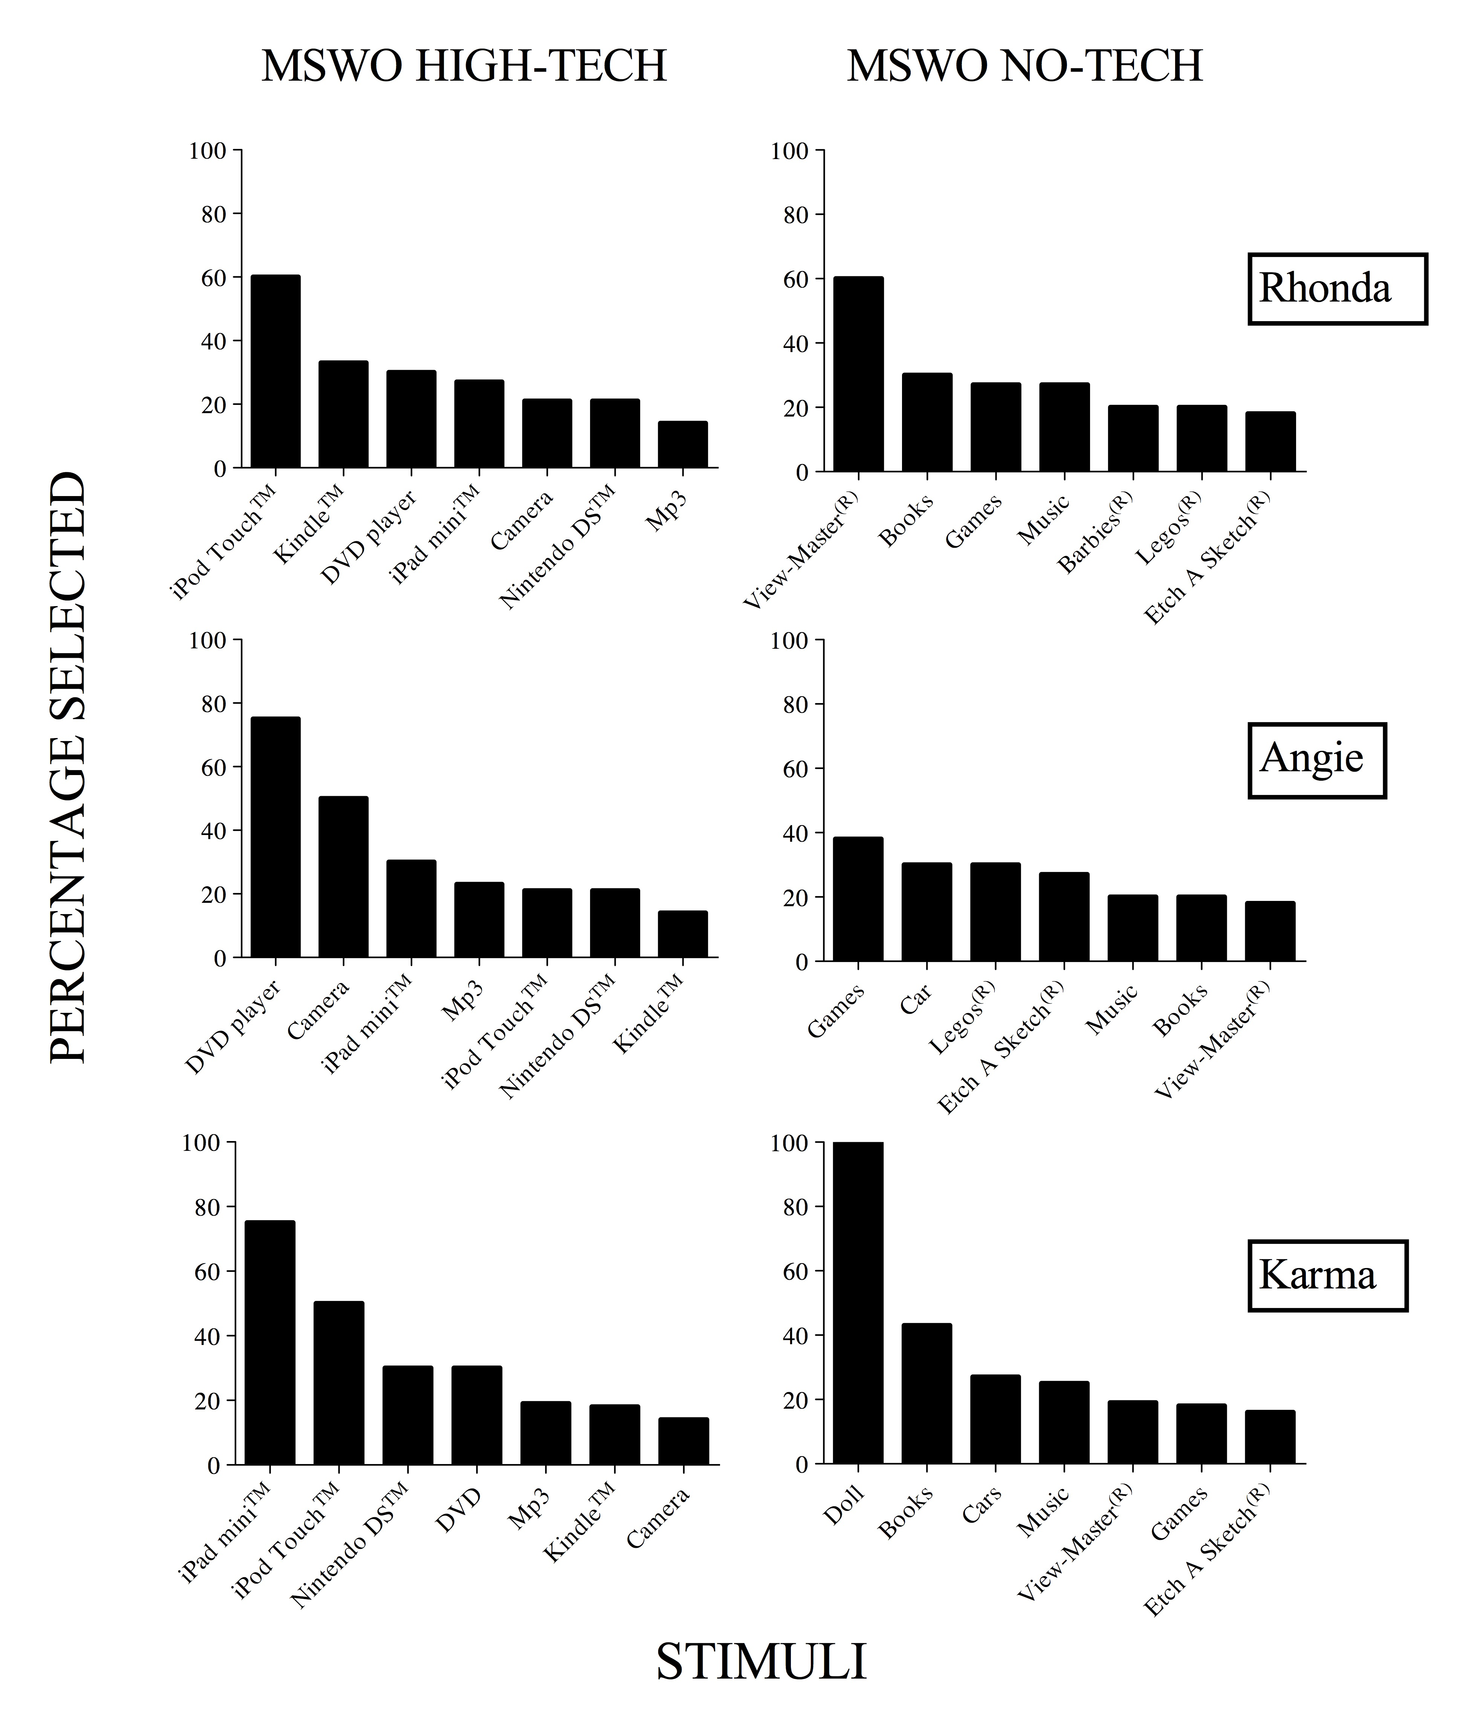
Figure 1. High-tech and no-tech MSWO results from Phase I. The stimuli with the highest percentage of selection for each participant were used in subsequent phases.

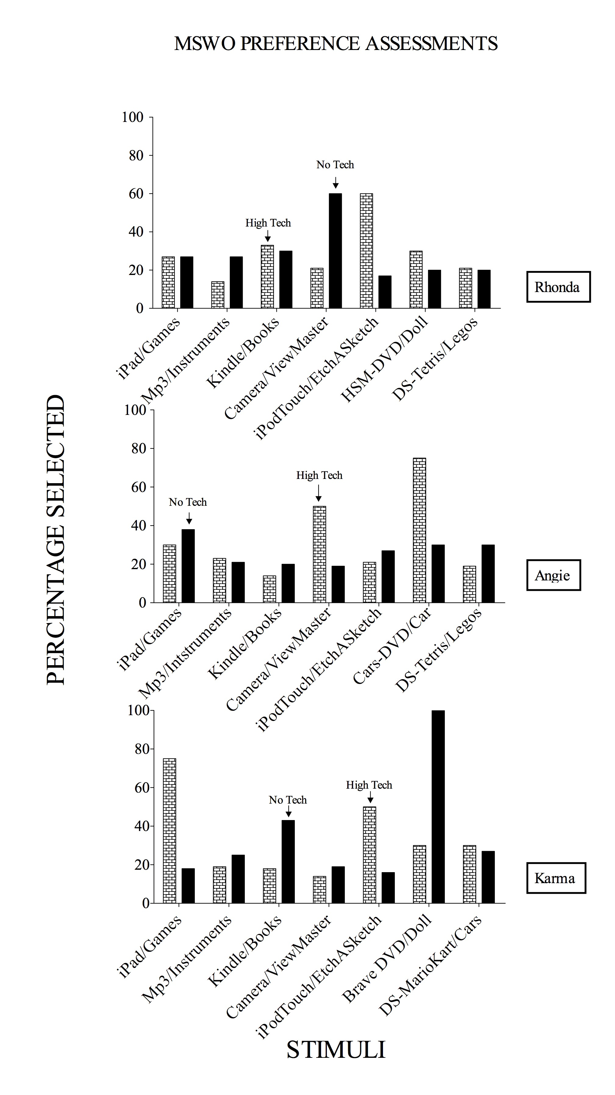
Figure 2. Data on percentage of selection per equated stimuli. The results demonstrate that participants’ preferences were not similar for equated stimuli.
value of) content type overrides preference for stimuli (in this case the stimuli might be thought of as the form in which content is presented) and that any apparent difference in preference observed across stimuli may simply be an artifact of differences in content. However, no apparent pattern or trend is evident from equating the stimuli across stimulus type, which leads to the conclusion that equating stimuli may not have been an important variable during Phase I.

Phase II

The purpose of Phase II was to investigate how preferences may change when magnitude of reinforcer access is manipulated, as well as to determine whether those changes are different for high- and no-tech items. Results for each participant are depicted in Figures 3 and 4. The results show that every participant preferred the highly preferred high-tech stimulus more than the highly preferred no-tech stimulus. Results of the preference assessment also show two patterns of results: participants either showed no differential preference for stimulus duration (see Rhonda, top panel of Figure 3) or preferred the long durations over short durations (see Angie and Karma, center and bottom panels of Figure 3).

Phase III

The purpose of Phase III was to evaluate interaction between duration of access time and stimulus type and the effects of that interaction on reinforcer efficacy. Results for each participant are discussed and shown separately below in Figures 5 through 9.
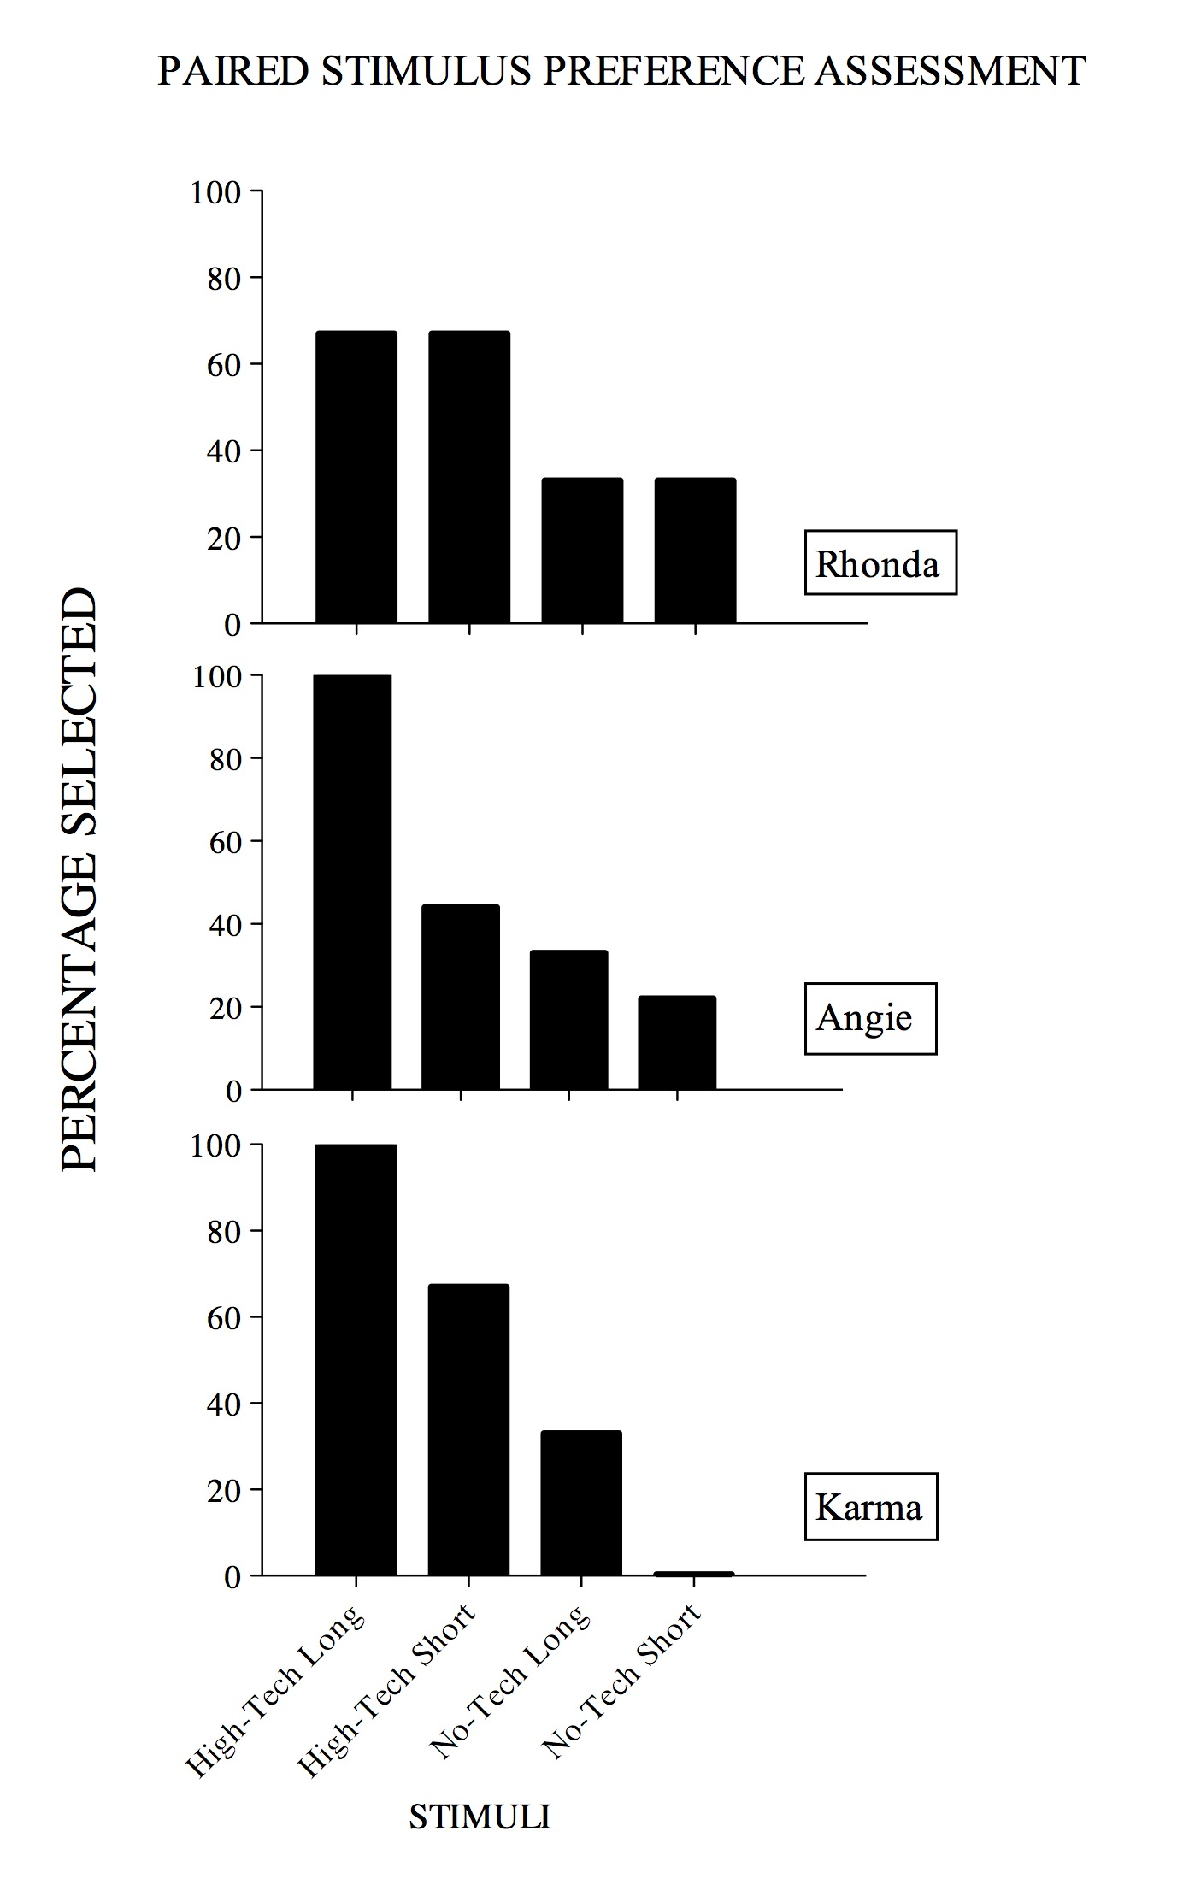
Figure 3. Data on percentage of selections during Phase II paired stimulus preference assessment. All participants preferred the high-tech item for either duration more than the no-tech item, and Angie and Karma preferred the high-tech item for the long duration while Rhonda did not demonstrate a preference for either duration.
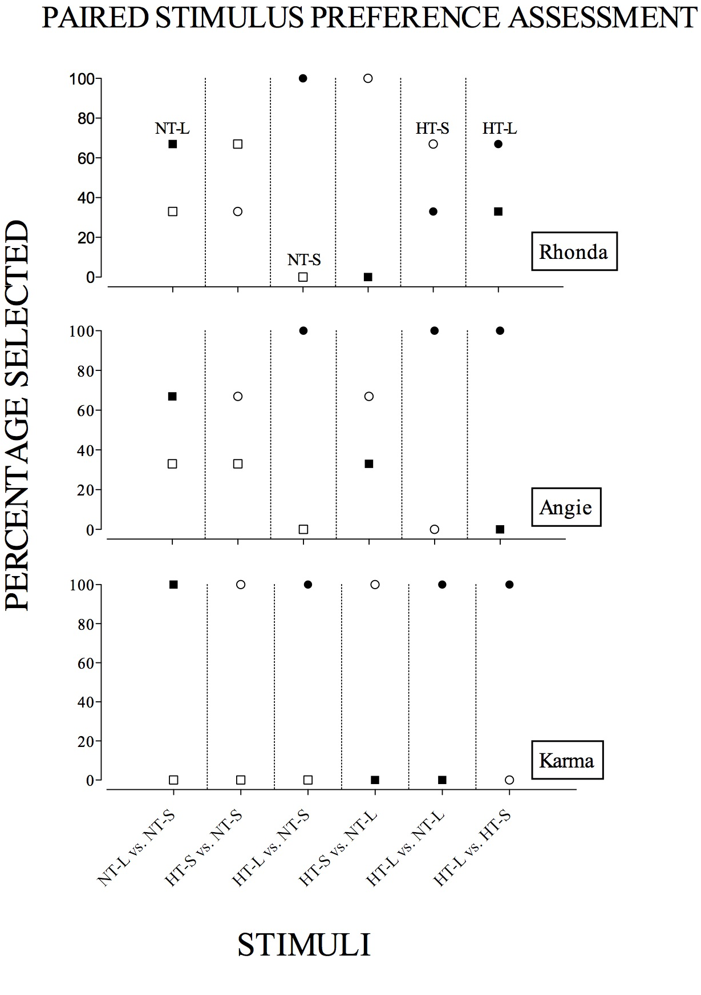
Figure 4. Paired stimulus preference assessment results depicting results per combination of items and durations presented.
Figure 5 depicts data within the ABCBC design used. During baseline, participants engaged in little or no responding. All participants engaged in more responding during high- and no-tech conditions relative to baseline, which indicates that for all participants both the high-tech and no-tech stimuli functioned as reinforcers. The purpose of Phase III was not only to assess whether the stimuli identified in Phase I functioned as reinforcers, but also to assess the degree that stimuli functioned as reinforcers depending on reinforcer duration and technology. During high-tech conditions, participants demonstrated an increasing trend in responding as reinforcer access durations were lengthened across sessions. In contrast, during no-tech conditions participants demonstrated a decreasing trend in responding as reinforcer access durations were lengthened across sessions; these effects can be seen in Figure 5.
Figure 6 has session durations labeled along the x-axis and depicts baseline sessions and the average of both high-tech phases and both no-tech phases. An upward trend in responding as reinforcer durations were increased is seen for Angie and Karma (middle and bottom panels, respectively). The average of Rhonda’s responding during high-tech phases does not demonstrate as clear of an upward trend. A downward trend is evident during the no-tech conditions for all participants. This demonstrates that as reinforcer durations were lengthened participants responded less to receive access to no-tech stimuli.
Figure 7 depicts data on break points for each participant. As discussed previously, break points are the point during a PR schedule that the participant stops responding, that is, the last completed schedule requirement within the PR schedule.
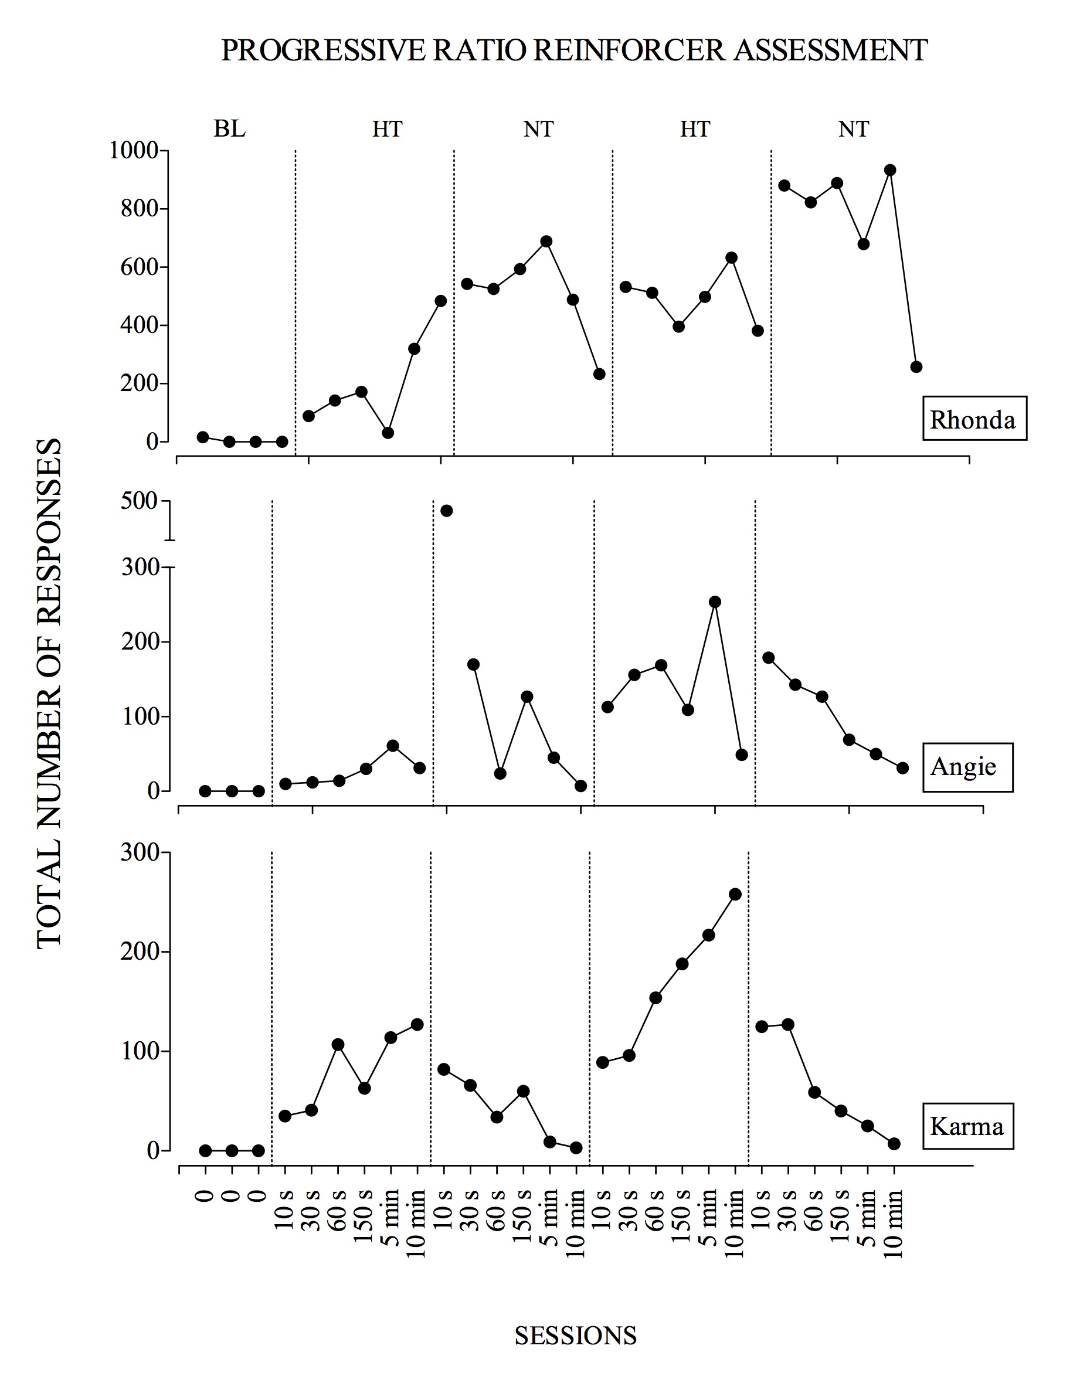
Figure 5. Progressive ratio reinforcer assessment results depicting total number of responses per session. Reinforcer durations for each session increase across sessions within each phase. During baseline participants did not receive reinforcement. During subsequent phases the durations increased across sessions but within phases.
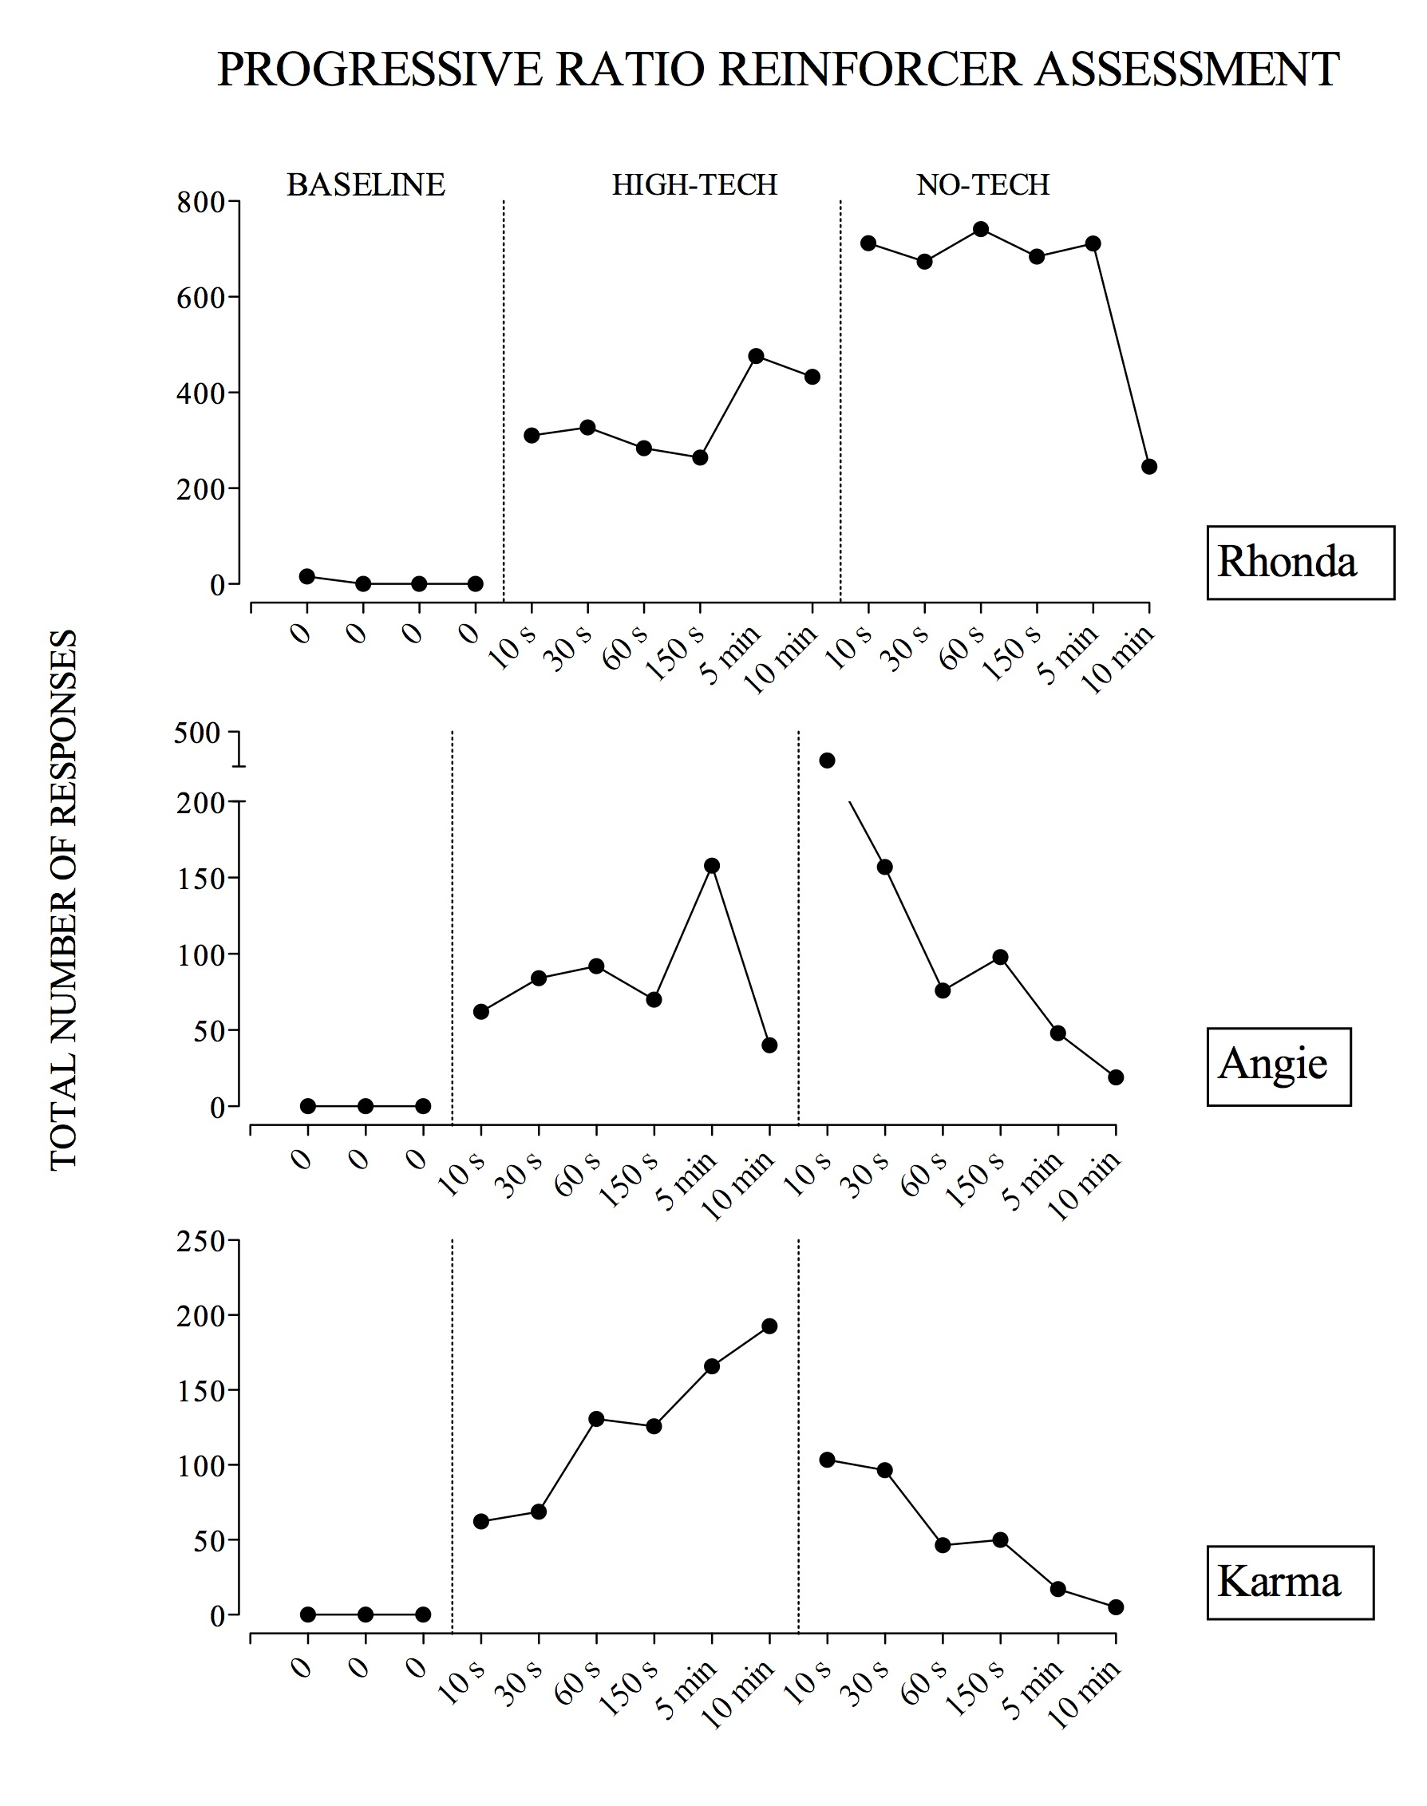
Figure 6. Data depicting the results of the progressive ratio reinforcer assessment. Data are averaged within high- and no-tech conditions. The results demonstrate that as reinforcer durations are increased the participants engaged in different patterns of responding depending on reinforcer stimulus type (i.e. high-tech versus no-tech).
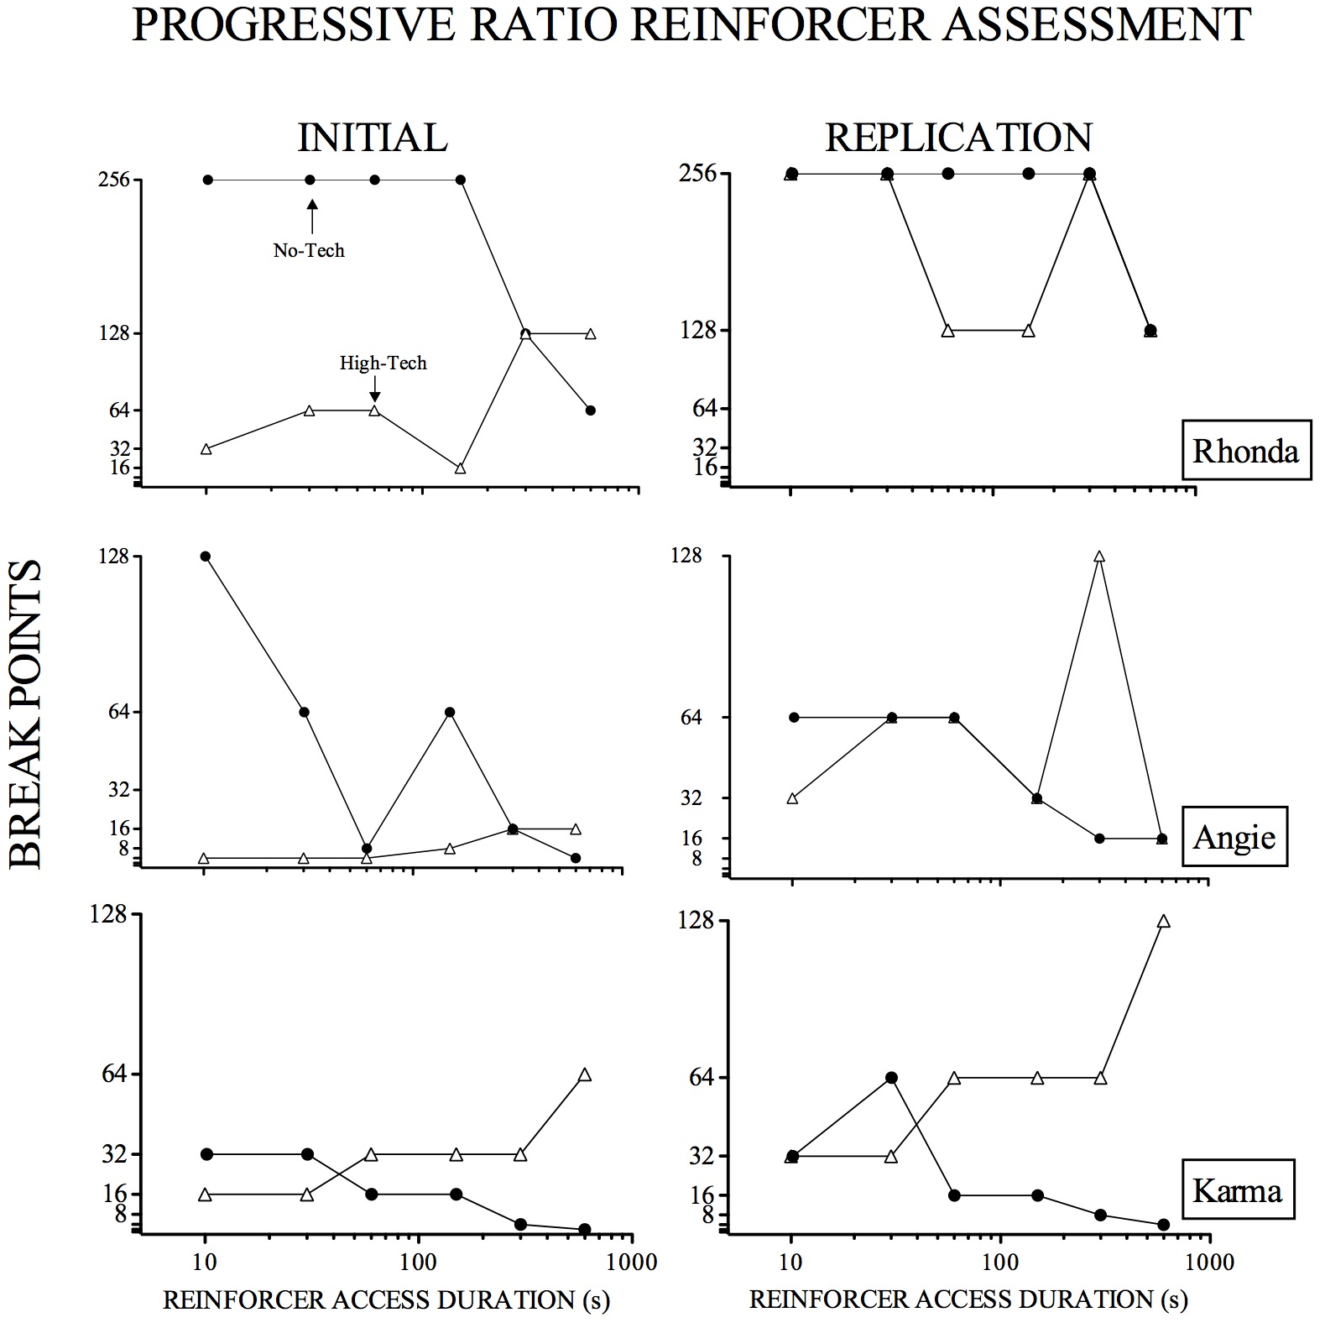

Figure 7. Data depicting break points for each participant during the progressive ratio reinforcer assessment plotted as a function of reinforcer access duration. Break points are the last completed schedule requirement obtained during the PR assessment.
Figure 7 depicts the initial high- and no-tech progressive ratio reinforcer assessment results in the left panel and the replication high- and no-tech progressive ratio reinforcer assessment results in the right panel. Each participant shows a different pattern of relations between reinforcer access duration and stimulus-type. A clear replication of effects is demonstrated by Karma’s data (bottom panel of Figure 7). As reinforcer access durations lengthened, Karma engaged in more responding to earn the high-tech item and engaged in less responding to earn the no-tech item. Results for Rhonda and Angie correspond to those from Karma during their initial exposures to the high-tech and no-tech conditions, but those results were not clearly replicated during the second exposure. During the initial exposure both Rhonda and Angie demonstrated more responding for the no-tech item at short durations of access and more responding for the high-tech item at the longest duration. However, during the replication of those phases, break points for both stimulus-types appeared to converge. For both participants, this manifested as increases in break points for high-tech stimuli from the first exposure to the second. Conversely, break points for no-tech stimuli appeared relatively similar across replications for Rhonda and Angie, which both generally showing an inverse relation between break point and reinforcer access.
Figure 8 depicts data on total number of responses as a function of reinforcer access durations. The pattern of responding for Rhonda (top panel Figure 8) demonstrates high levels of responding for the no-tech item during all durations except the 10-min duration where responding decreased relative to previous sessions. Responding during high-tech conditions was lower and stable but increased to higher levels during the 5-min
Figure 8. Data depicting total number of responses per session across both high- and no-tech conditions. All participants engaged in more responding to earn access to the no-tech item at the shortest durations and the high-tech item at the longest duration.

and 10-min access time conditions. These results demonstrate that for Rhonda, the no-tech item sustained greater overall levels of responding than the high-tech item except when the reinforcer access duration was 10 min. Contrary to Figure 7, Figure 8 demonstrates a replication of Rhonda’s pattern of responding across the initial conditions and the replication conditions. The middle panel of Figure 8 depicts Angie’s overall pattern of responding. As reinforcer access duration lengthened, Angie responded more for the high-tech item and less for the no-tech item. Angie’s results show a clear decreasing trend in responding during the no-tech condition as reinforcer access time increased. During high-tech conditions, Angie’s results are more variable, during the initial high- and no-tech conditions Angie engaged in more responding to gain access to the no-tech item than to gain access to the high-tech item until the access duration reached 5 min, at which point Angie engaged in more responding to gain access to the high-tech item for the 5-min and 10-min access times. During the replication, Angie engaged in more responding to gain access to the high-tech item for all durations except the 10-s duration. Karma’s results (Figure 8 bottom panel) demonstrate that as reinforcer access durations increased, responding for the no-tech item decreased and conversely as access durations increased responding for the high-tech item increased.
Figure 9 depicts the rate of responding for each participant per session. The top panel depicts data from the high-tech conditions and the bottom panel depicts data from the no-tech conditions. The open data paths are data from the replication phases and the closed data paths are data from the initial high- and no-tech conditions. All participants engaged in higher rates of responding during replication of the high- and no-tech phases.
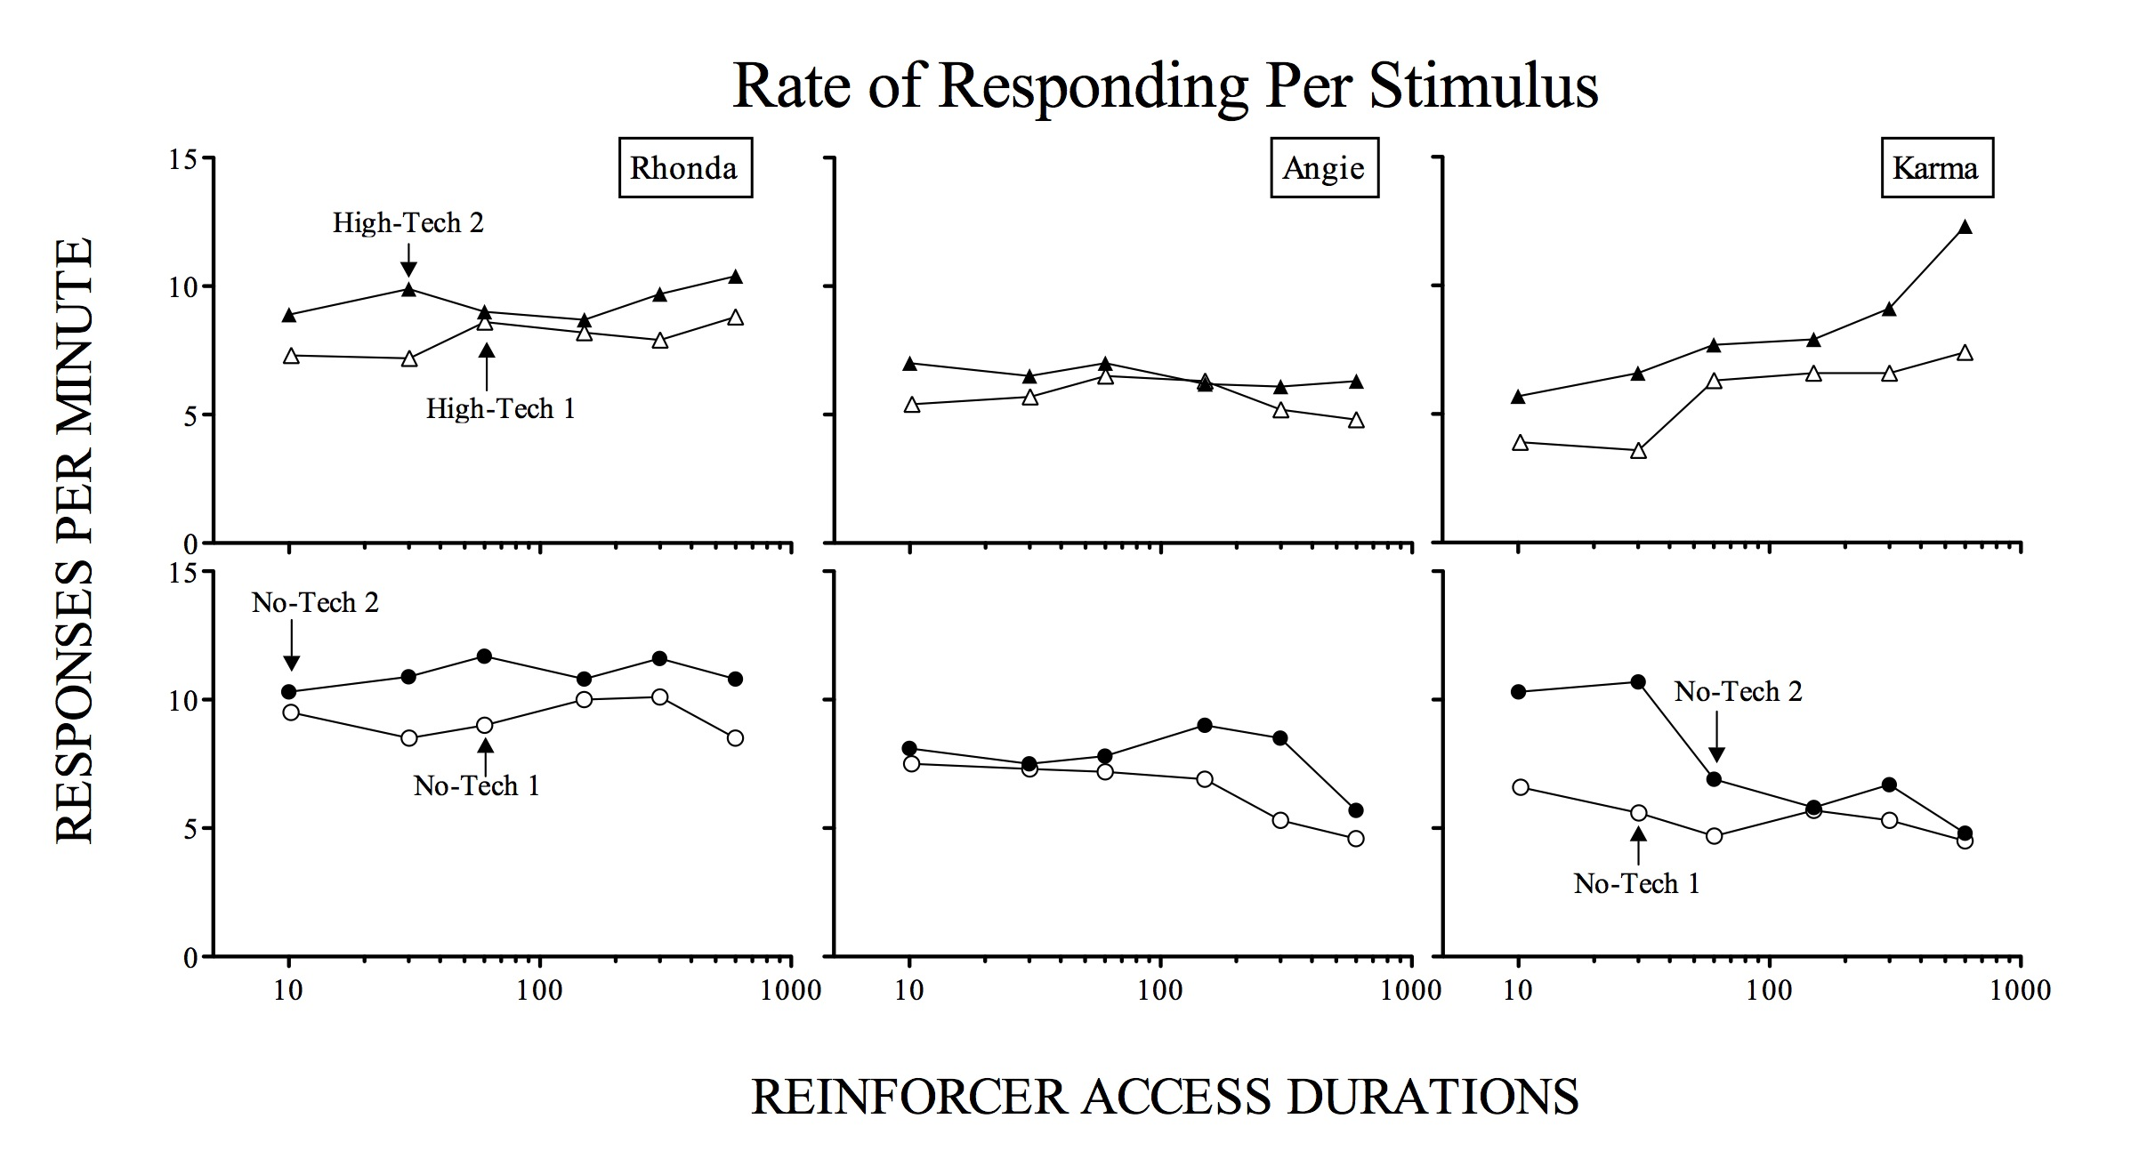
Figure 9. Data depicting rate of responding for each participant during the initial B and C phases and the replication B and C phases. The closed symbols depict rates of responding during replication phases and the open symbols depict rates of responding during initial phases. Results indicate higher rates of responding during the replication high- and no-tech phases.

CHAPTER IV
DISCUSSION

In Phase I we used preference assessments to identify highly preferred no-tech and high-tech stimuli for each participant. In Phase II, we examined participants’ preferences for the highest preferred stimuli identified in Phase I when delivered for both short (30 s) and long (10 min) durations. Two of the three participants (Angie and Karma) displayed preferences indicative of sensitivity to reinforcer access duration, in which longer durations were more preferred over shorter durations. A third participant, Rhonda, appeared indifferent to reinforcer access duration and approached stimuli associated with the long and short durations equally. However, all three participants showed preferences toward high-tech stimuli over no-tech stimuli.
In Phase III, we attempted to assess differences in the reinforcing value of stimuli provided for different durations across both stimulus types. For all three participants, we found that the reinforcing value (as indexed by break points, etc.) of stimuli changed differently as a function of access duration depending on stimulus type. For example, at the 10-min access duration, all participants engaged in more responding for the high-tech item than the no tech item. The clearest and perhaps most intuitive pattern can be seen in the bottom panel of Figure 7 for Rhonda, where the break points for high-tech stimuli appear to increase as a function of reinforcer access duration but break points for no-tech stimuli appear to decrease.
Overall, the results demonstrate how the above preparation could detect and characterize the interaction between reinforcer access time and reinforcer value. Reinforcer value changed as access durations were varied. In at least one participant, the value of high-tech stimuli increased with access durations whereas the value of no-tech stimuli was initially high but decreased as access duration increased. Thus, it could be that for some people, some stimuli (e.g., movies, and video games) might become more reinforcing the longer they are used while other stimuli become less reinforcing. Results from this study correspond to those from previous studies showing that the value of a reinforcer changes depending on the duration of access it is provided (e.g., Trosclair-Lassarre et al., 2008). In addition, this study contributes data supporting the supposition that the value of reinforcers change across time in ways that depend on the particulars of the stimulus used. For example, data from Trosclair-Lassarre and colleagues (2008) suggest the value of a reinforcer might only increase with access duration—this corresponds to the intuitive view of reinforcer magnitude “more is better.” However, data from this study add to the literature by characterizing both positive and negative correlations between reinforcer value and access duration. Thus, one important finding could be that the reinforcer value of some stimuli may change differently than those of other stimuli with changes in reinforcer access duration.
Given the results, this study may extend previous research related to reinforcer magnitude and preference by assessing the effects of the interaction between duration of access and high-tech stimuli on reinforcer preference and efficacy. This study provides evidence that stimulus type and duration of access interact to influence responding. Participants demonstrated preference for high-tech items when duration of access was longer, but did not demonstrate a preference for no-tech items when duration of access was longer, providing evidence that duration of access and the interaction of access time and stimulus type may influence preference and reinforcer efficacy.
This study has implications for using high-tech and no-tech items as reinforcers in clinical and educational settings. A teacher using high- or no-tech items as reinforcers to increase appropriate behavior may have limited durations of time to provide access to items. This study provides evidence of no-tech items being more effective reinforcers at shorter durations. Using this information, the teacher may see better results using no-tech items as reinforcers given the short access time. In that same setting, use of a high-tech item may not be effective given the time constraints of the classroom. In contrast, when providing a high-tech item for reinforcement, a caregiver or teacher may obtain better results when providing the item for a long duration. The results may provide evidence that high-tech stimuli are more effective reinforcers when duration of access time is longer. In a clinical setting if there is more time to provide reinforcement and a client is highly motivated by receiving access to a personal gaming device, the clinician may see better results if they provide access to the high-tech device for longer durations of time. Both of these examples highlight how this study provides evidence of the importance of assessing the effects of duration of access time and stimulus type when providing high-and no-tech stimuli as reinforcers. Clinicians could use similar procedures as these to select reinforcer access durations that maximize rates of academic or appropriate behavior.
One interesting finding of the current study is the correspondence between Phase II and Phase III. The results of Phase III did not consistently correspond with results of Phase II. For Angie and Karma (see middle and bottom panels of Figures 3 and 8) results did coincide in that they demonstrated a preference for the high-tech stimulus at longer durations during Phase II and responded more in order to gain access to the high-tech stimulus for longer durations during Phase III. Angie and Karma preferred the high-tech stimulus for longer durations over the no-tech stimulus for long durations (during Phase II), and also demonstrated less response persistence for the no-tech stimulus as durations of access were increased (during Phase III).
Results for Rhonda do not show a pattern of coinciding. Although she preferred the high-tech device more than the no-tech item during Phase II, she demonstrated more responding during Phase III to earn the no-tech item except at the 10-min access duration (see Figure 8 top panel). Although many studies on correspondence across preference and reinforcer assessments find a general tendency for items to be similarly rank ordered across assessment types, it is also not uncommon for the assessments to disagree (see DeLeon & Iwata, 1996 for example). One possible explanation for the disagreement may be that Rhonda was insensitive to the reinforcement contingencies as sessions progressed or that the task gained reinforcing value due to extended exposure to engaging in the task repeatedly over the course of the study. Because sessions were open-ended and did not end until 2 min of no responding elapsed, participants could engage in responding indefinitely. Rhonda in particular engaged in more responding than other participants (e.g. 934 responses in one session). Anecdotally, Rhonda’s staff at the sheltered workshop reported that she is a hard worker and has a long history of working for long periods of time doing menial tasks. Rhonda engaged in more overall responses as the course of the study continued, (see top panel of Figure 5). Perhaps Rhonda’s responding became less sensitive to the programmed reinforcers as the study continued. Future studies could examine procedures similar to these with participants who do not possess a history of working for long periods of time under conditions of delayed reinforcement. Further evidence of unanticipated changes in responding is demonstrated in Figure 9. All participants engaged in higher rates of responding during the replication conditions of the study than during the initial implementation of the two conditions. This may indicate a practice effect, that is, participants engaged in higher response rates as a result of repeatedly engaging in the target response. Participants also engaged in overall higher levels of responding during the replication conditions relative to the initial conditions (Figure 8) This also may be due to a practice effect where engaging in the target response repeatedly over time resulted in increased fluency in responding.
Another interesting finding of the current study is the differences in data interpretation and the effect the visual display has upon conclusions regarding the data. The data depicted in Figures 7 and 8 may lead to differing interpretations of the results. The break points depicted in Figure 7 depict the last schedule requirement the participant engaged in for each session (and reinforcer duration). The number of total responses depicted in Figure 8 display the total number of responses engaged in per session. Analyzing the data using total number or responses may be a more reliable measure of reinforcer value in PR schedules because break points do not capture all responses and in some cases leave out a large number of responses. For example, in Figure 8, when looking at Rhonda’s data during the replication conditions, the high- and no-tech data paths are more separated than the data paths depicted in Figure 7. Another example of different interpretations is evident when looking at Angie’s responding during the replication conditions in Figure 8 compared to Figure 7. When looking at break points the data paths appear to converge and responding across the high- and no-tech conditions appear similar. Conversely, when looking at total responses it is clear that Angie responded more to gain access to the high-tech item for all durations except the 10-s access time.
Different interpretations emerge when analyzing the PR break points versus the total number of responses. As mentioned previously, only one participant demonstrated clear replication effects when analyzing the data using break points. However, when the data are examined using total responses, different conclusions may be drawn (compare results in Figures 7 and 8). Break points are a commonly used method of analyzing data from PR assessments. In the case of this study the data can be interpreted differently based upon the presentation of the data and on the unit of analysis. This may highlight the importance of examining data in multiple ways. This has implications for the field of behavior analysis, which relies upon visual analysis in drawing conclusions from data. Future research may further examine the different interpretations drawn from different visual displays of the same data.
One possible limitation of this study may be that the researcher only conducted a single operant procedure and did not conduct a concurrent operant procedure to assess reinforcer efficacy. The results of Phase II were not predictive of the results of Phase III for all participants, which may be due to Phase II being a concurrent operant arrangement while Phase III was a single operant arrangement. Future research could examine the effects of using both concurrent or single operant arrangements to assess preference and reinforcer efficacy. On the other hand, preference assessments like those used in Phase II are advantageous because they are quick and because they produce data that have a tendency to predict the outcomes of reinforcer assessments. But, an examination of the literature reveals that perfect correspondence between the outcomes of preference and reinforcer assessments is actually quite rare.
Another possible limitation is that preference for the items may not be due to the differences in type of stimulus (high-tech or no-tech). It should be noted that although I attempted to match stimulus content across high- and no-tech stimuli, this does not ensure that participants were choosing according to stimulus type. I attempted to equate the content of stimuli across modalities but I could not equate stimuli across all possible dimensions. For example, I did not match stimuli using shape, color, or size. Participants may have been more sensitive to other dimensions. Further, the responding may not be due to different stimulus types, but instead due to the item being more preferred than the other stimuli. Results from at least one study speak to this matter. Keyl-Austin, Samaha, Bloom, and Boyle (2012) compared the effectiveness of various edible items as reinforcers during long-duration sessions and found that the value of both highly and moderately preferred edibles decreased with exposure but that highly preferred stimuli simply decreased to a lesser degree. Thus, differences in preference alone do not seem to account for qualitative changes in the value of reinforcers as a function of reinforcer duration observed in this study. Future research may extend this area of research by conducting both single operant reinforcer assessments and concurrent operant reinforcer assessments when evaluating the interaction of reinforcer magnitude and high-tech stimuli. Future research may also be conducted replicating this research but ensuring that the high-tech stimulus and the no-tech stimulus initially evoke similar levels of responding when the duration of access time is held constant, to assess the relative preference of the two stimuli.
Future research could evaluate the influence of specific types of high-tech items and the effects of these types of stimuli on responding, such as particular games and applications on a tablet device and how the different uses of the device affect the device’s reinforcing efficacy. Researchers could also assess the influence of learning histories with high-tech stimuli and the effects of learning history on preference and reinforcing efficacy. As use of high-tech items continues to increase, more research will be needed to assess the interaction of high-tech stimuli with other dimensions of reinforcement. More research will also be needed in the general field of applied behavior analysis as to whether this type of stimuli affects the populations typically served by behavior analysts, and how this type of stimuli affects human behavior overall. This research is a step forward in an area where additional research is needed. This study begins to answer questions surrounding duration of access time and how other dimensions of reinforcement interact to influence responding.

REFERENCES

Behrmann, M., & Jerome, M. K. (2002). Assistive technology for students with mild disabilities (Report No. ED463595). Retrieved from http://www.eric.ed.gov/ PDFS/ED463595.pdf
Bouck, E. C., Okolo, C. M., & Courtad, C. A. (2007). Technology at home: Implications for children with disabilities. Journal of Special Education Technology, 22(3), 43-56.
Broster, B. S., & Rankin, C. H. (1994). Effects of changing interstimulus interval during habituation in Caenorhabditis elegans. Behavioral Neuroscience, 108, 1019-1029.
Carey, A. C., Friedman, M. G., & Bryen, D. N. (2005). Use of electronic technologies by people with intellectual disabilities. Mental Retardation, 43, 322-333.
Cooper, J. O., Heron, T. E., & Heward, W. L. (2007). Applied behavior analysis (2nd ed.). Upper Saddle River, NJ: Pearson.
DeLeon, I. G., & Iwata, B. A. (1996). Evaluation of a multiple-stimulus presentation format for assessing reinforcer preferences. Journal of Applied Behavior Analysis, 29, 519-533. doi: 10.1901/jaba.1996.29-519
Fisher, W. W., Piazza, C. C., Bowman, L. G., Hagopian, L. H., Owens, J. C., & Slevin, I. (1992). A comparison of two approaches for identifying reinforcers for persons with severe and profound disabilities. Journal of Applied Behavior Analysis, 25, 491-498. doi: 10.1901/jaba.1992.25-491
Glover, A. C., Roane, H. S., Kadey, H. J., & Grow, L. L. (2008). Preference for reinforcers under progressive- and fixed-ratio schedules: A comparison of single and concurrent arrangements. Journal of Applied Behavior Analysis, 41, 163-176. doi: 10.1901/jaba.2008.41-163
Hoch, H., McComas, J. J., Johnson, L., Faranda, N., & Guenther, S. L. (2002). The effects of magnitude and quality of reinforcement on choice responding during play activities. Journal of Applied Behavior Analysis, 35, 171-181. doi: 10.1901/jaba.2002.35-171
Iwata, B. A., Dorsey, M. F., Slifer, K. J., Bauman, K. E., & Richman, G. S. (1982/1994). Toward a functional analysis of self-injury. Journal of Applied Behavior Analysis, 27, 197-209. (Reprinted from Analysis and Intervention in Developmental Disabilities, 2, 3-20, 1982)

Keyl-Austin, A. A., Samaha, A. L., Bloom, S. E., & Boyle, M. A. (2012). Effects of preference and reinforcer variation on within-session patterns of responding. Journal of Applied Behavior Analysis, 45, 637–641. doi:10.1901/jaba.2012.45-637
Kagohara, D. M., van der Meer, L., Ramdoss, S., O’Reilly, M. F., Lancioni, G. E., Davis, T. N., … Sigafoos, J. (2013). Using iPods and iPads in teaching programs for individuals with developmental disabilities: A systematic review. Research in Developmental Disabilities, 34, 147-156. Retrieved from http://dx.doi.org/ 10.1016/j.ridd.2012.07.027
McSweeney, F. K., Kowal, B. P., Murphy, E. S., & Weidiger, R. S. (2005). Stimulus change dishabituates operant responding supported by water reinforcers. Behavioural Processes, 70, 235-246. doi: 10.1016/j.beproc.2005.07.004
McSweeney, F. K., & Roll, J. M. (1998). Do animals satiate or habituate to repeatedly presented reinforcers? Psychonomic Bulletin & Review, 5, 428-442.
Murphy, E. S., McSweeney, F. K., Smith, R. G., & McComas, J. J. (2003). Dynamic changes in reinforcer effectiveness: Theoretical, methodological, and practical implications for applied research. Journal of Applied Behavior Analysis, 36, 421-438. doi: 10.1901/jaba.2003.36-421
Pew Research Internet Project. (2014). Three technology revolutions. Retrieved from http://www.pewinternet.org/Trend-Data-(Adults)/Device-Ownership.aspx
Roane, H. S., Lerman, D. C., & Vorndran, C. M. (2001). Assessing reinforcers under progressive schedule requirements. Journal of Applied Behavior Analysis, 34, 145-167. doi: 10.1901/jaba.2001.34-145
Steinhilber, J., & Johnson, C. (2007). The effects of brief and extended stimulus availability on preference. Journal of Applied Behavior Analysis, 40, 767-772. doi: 10.1901/jaba.2007.767-772
Trosclair-Lasserre, N. M., Lerman, D. C., Call, N. A., Addison, L. R., & Kodak, T. (2008). Reinforcement magnitude: An evaluation of preference and reinforcer efficacy. Journal of Applied Behavior Analysis, 41, 203-220. doi: 10.1901/jaba.2008.41-203
Weatherly, J. N., McSweeney, F. K., & Swindell, S. (2004). Within-session rates of responding when reinforcer magnitude is changed within session. Journal of General Psychology, 131, 5-16.

APPENDIX
Caregiver Interview Questions

- Does your child/ward have a diagnosed intellectual or developmental disability?
- If so, what is your child/ward’s disability diagnosis?
- Has your child/ward ever used a high-tech device?
  - Examples of high-tech devices are: tablet computers (like an iPad), personal video players (a portable DVD player), personal gaming devices (like a Nintendo DSTM), Mp3 devices (like an iPodTM), eReader devices (like a Nook®), or a laptop computer.
- If so, how often does your child/ward use high-tech devices?
- Does your child/ward have a history or problem behavior?
  - Examples of problem behavior include aggression (such as hitting or kicking another person), property destruction (such as throwing or breaking objects), or extreme non-compliance (such as engaging in tantrums or screaming to avoid doing something they have been asked to do).
- If so, how often does problem behavior occur and when was the last time problem behavior occurred?

Client Interview Questions

*We will not ask clients about their own disability diagnosis or problem behavior. We will interview caregivers or staff regarding client diagnoses and problem behavior.
- Have you ever used a high-tech device?
  - Examples of high-tech devices are: tablet computers (like an iPad), personal video players (a portable DVD player), personal gaming devices (like a Nintendo DSL), Mp3 devices (like an iPod), eReader devices (like a Nook), or a laptop computer.
- If so, how often do you use high-tech devices?

